South Fork Eel River Water Allocation Model (SEWAM)
  - Model documentation

2021 January
Doug Chalmers
Chuck Young

Prepared for:
State Water Resources Control Board
Division of Water Rights
California Environmental Protection Agency

Project Information:
SEI. 2019. South Fork Eel River Water Allocation Model. Draft. Prepared for the State Water Resources Control Board, California Environmental Protection Agency, Sacramento, CA.

Table of contents
1 Project overview 9
1.1 Organization and contents of this document 11
1.2 Water Evaluation and Planning System 11
1.3 Acknowledgements 11
2 Water Evaluation and Planning System 12
2.1 General description 12
2.2 Approach 13
2.3 Study definition 13
2.4 Current accounts 14
2.4.1 Scenarios 14
2.4.2 Evaluation 14
2.5 Water allocation 14
2.6 Hydrology 16
2.7 Solution methodology 16
3 Schematic and model domain 18
3.1 Study definition 18
3.2 System component overview 18
3.3 Rivers 18
3.4 Groundwater 19
3.5 Demand sites 20
3.5.1 Transmission link objects and diversion points 21
3.5.2 Amount used demand node objects 22
3.5.3 Reservoir objects 23
3.5.4 Return flow objects 23
3.6 Flow requirements 24
3.7 Streamflow gauges 24
4 Demand site properties 26
4.1 Diverted total transmission links 26
4.1.1 Maximum flow volume 26
4.2 Reservoirs 26
4.2.1 Storage capacity 26
4.2.2 Priority date 26
4.2.3 Priority 27
4.3 Amount used demand nodes 27
4.3.1 Daily demand 27
4.3.2 Consumption 27
4.3.3 Priority date 27
4.3.4 Demand priority 27
5 Key expressions 28
5.1 Sensitivity scenario 28
5.2 Instream flow target scenario 28
5.3 Cannabis demand fraction 29
5.4 eWRIMS demand fraction 30
5.5 eWRIMS demand scenario 30
5.6 Percent of flow 30
5.7 Water month type 31
5.8 Water year type (inactive as of Jan 2021) 31
5.9 Unpermitted priority 32
5.10 Flow requirement priority 32
5.11 Priority date trigger 32
5.12 Use type distribution orders (inactive as of Jan 2021) 33
5.13 eWRIMS Storage Toggle 33
5.14 Cannabis Storage Toggles 33
6 Model Results 35
6.1 Diverted total results 35
6.2 Model Tagsn 36
7 Water Use Report 37
7.1 Introduction 39
7.1.1 Background 40
7.2 Simulation scenarios 42
7.3 eWRIMS applications demand estimates 47
7.3.1 Estimating eWRIMS diverted total 47
7.3.2 Estimating eWRIMS amount used and return flows 54
7.3.3 Classifying applications into beneficial use groups 65
7.3.4 Calculating average monthly distributions by beneficial use group 73
7.3.5 Priorities of eWRIMS applications 78
7.4 Cannabis imagery demand estimates 78
7.4.1 Estimating cannabis imagery cultivation area 79
7.4.2 Estimating cannabis imagery annual diverted total 81
7.4.3 Estimating cannabis imagery monthly amount used distribution 82
7.4.4 Estimating cannabis imagery monthly diverted total distribution 83
7.4.5 Estimating cannabis imagery return flows 85
7.5 Illegal domestic demand estimates 86
7.5.1 Population for illegal domestic demands 86
7.5.2 Estimating illegal domestic annual amount used per capita 87
7.5.3 Estimating illegal domestic monthly amount used distribution 88
7.5.4 Estimating illegal domestic consumptive use fraction and return flows 89
7.6 Department of Drinking Water municipal demand estimates 89
7.6.1 Estimating DDW municipal amount used 89
7.6.2 Estimating DDW municipal consumptive use fraction and return flows 90
8 References 91

Abbreviations
AU Amount Used
BU Beneficial Use
CDFW California Department of Fish & Wildlife
DDW Department of Drinking Water
DT Diverted Total
DWR California Department of Water Resources
eWRIMS Electronic Water Rights Information Management System
LP Linear Programming
NC RWQCB North Coast Regional Water Quality Control Board
SEI Stockholm Environment Institute
SEWAM South Fork Eel River Water Allocation Model
SFER South Fork Eel River
State Water Board State Water Resources Control Board
UDC User-Defined Constraints
USGS United States Geological Survey
WAP California Water Action Plan
WEAP Water Evaluation and Planning
WRUDS Water Rights Use Data Set

This page left blank intentionally.

Project overview
This document describes the development of the daily time-step South Fork Eel River Water Allocation Model (SEWAM) (Figure 1.1). SEWAM has been developed within the Water Evaluation and Planning system (WEAP) software developed and maintained by the Stockholm Environment Institute (SEI).
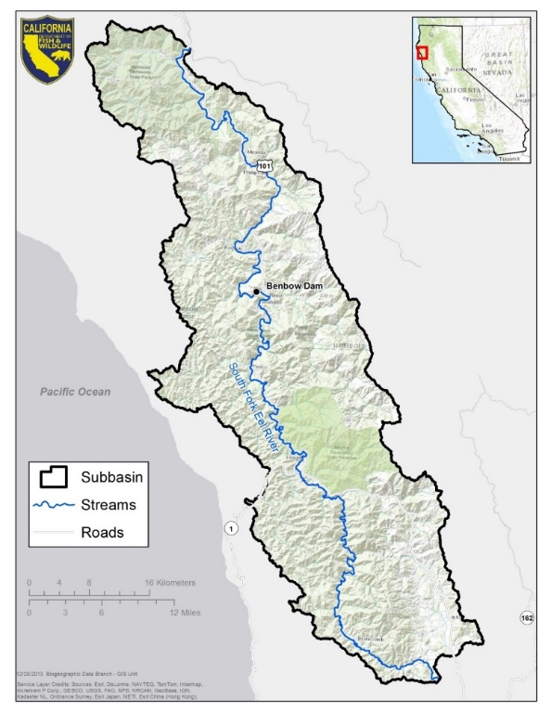
Figure 1.1 Map of South Fork Eel River watershed.
Source: CDFW, 2018
The California Natural Resources Agency, the California Environmental Protection Agency, and the California Department of Food and Agriculture developed the California Water Action Plan (WAP), released on January 22, 2014 (CNRA, 2014). The WAP has been developed to meet three broad objectives:
- More reliable water supplies;
- The restoration of important species and habitat; and
- A more resilient, sustainably managed water resources system (water supply, water quality, flood protection, and environment) that can better withstand inevitable and unforeseen pressures in the coming decades.
Action Four of the WAP, to “Protect and Restore Important Ecosystems,” contains a sub-action that states the following:
The State Water Resources Control Board and the Department of Fish and Wildlife will implement a suite of individual and coordinated administrative efforts to enhance flows statewide in at least five stream systems that support critical habitat for anadromous fish. These actions include developing defensible, cost-effective, and time-sensitive approaches to establish instream flows using sound science and a transparent public process. When developing and implementing this action, the State Water Resources Control Board and the Department of Fish and Wildlife will consider their public trust responsibility and existing statutory authorities such as maintaining fish in good condition.
Through a coordinated effort between the State Water Resources Control Board (State Water Board) and California Department of Fish and Wildlife (CDFW), the following stream systems have been identified as a starting point for the WAP effort:
- Shasta River, tributary to the Klamath River, Siskiyou County
- South Fork Eel River, tributary to the Eel River, Humboldt and Mendocino Counties
- Mark West Creek, tributary to the Russian River, Sonoma County
- Mill Creek, tributary to the Sacramento River, Shasta and Tehama Counties
- Ventura River, Santa Barbara and Ventura Counties
The State Water Board and CDFW are currently working to identify potential actions that may be taken to enhance and establish instream flow for anadromous fish in these five priority streams and other streams of importance to the WAP objectives.
The development of water allocation models will enable the State Water Board to evaluate the impact of instream flow policy options on water rights holders. A critical step in developing a water allocation model is to estimate diversions in the subject watershed.
This document specifically focuses on the South Fork Eel River (SFER) watershed and describes SEWAM as developed in WEAP.

Organization and contents of this document
This report describes the methods and assumptions used to develop SEWAM. The first chapters of this document provide background information, including overviews of the project modeling platform and WEAP’s Data View. Later chapters provide context for the SFER watershed. The final chapters in this report discuss model validation and the limitations of SEWAM.
The contents of each chapter are as follows:
Chapter 1, Project overview, provides general background and describes the purpose of SEWAM and this document.
Chapter 2, Water Evaluation and Planning System, describes the WEAP software used to develop SEWAM.
Chapter 3, Schematic and model domain, describes development of the SEWAM schematic, constructed using WEAP’s internal water resources objects.
Chapter 4, Demand site properties, describes the detailed properties of the demand objects in the schematic.
Chapter 5, Key expressions, describes the Key Expressions used in the WEAP data tree.
Chapter 6, Model Results
This section describes the tags and favorites.

Diverted total results
There are a total of 18 result favorites describing the DT results in WEAP for SEWAM. Each of the 18 result favorites is comprised of a combination of one result variable, demand type, and area, as shown in Table 6.1.
Table 6.1 Diverted total result combination components
Each result favorite saved in WEAP is a combination built from one component from each column.
1. Result Variables | 2. Demand Types | 3. Area
DT Potential | Cannabis Imagery (Can) | Contributing Area (CA)
DT Supplied | eWRIMS (eWR) | Intermediate Area (INT)
 | Illegal Domestic (IlD) | Local Subwatershed (Local)
While the demand types refer to the cannabis imagery, eWRIMS, and illegal domestic demands, as covered in chapter 7, the result variables and area terms in Table 6.1 are defined below:
Result Variables
- DT Potential:
  - Refers to the flow of water requested to be diverted out of the stream via the DT transmission link (see of each demand site).
- DT Supplied

- DT_Potential_Can_CA
- DT_Potential_Can_INT
- DT_Potential_Can_Local
- DT_Potential_eWR_CA
- DT_Potential_eWR_INT
- DT_Potential_eWR_Local
- DT_Potential_IlD_CA
- DT_Potential_IlD_INT
- DT_Potential_Ild_Local
- DT_Supplied_Can_CA
- DT_Supplied_Can_INT
- DT_Supplied_Can_Local
- DT_Supplied_eWR_CA
- DT_Supplied_eWR_INT
- DT_Supplied_eWR_Local
- DT_Supplied_IlD_CA
- DT_Supplied_IlD_INT
- DT_Supplied_ILD_Local
- Flow Requirement Coverage
- Instream Flow Requirement
- Reservoir Storage Volume
- Streamflow
Unmet Flow Requirement

Model Tagsn

Water Use Report, describes the assumptions and methods for estimating water demands of Electronic Water Rights Information Management System (eWRIMS) applications and cannabis imagery areas.
Chapter 8, References, presents sources cited in this report.

Water Evaluation and Planning System
The WEAP software has been under development by SEI for nearly 20 years. The software provides a comprehensive suite of tools for simulating water resources systems including rainfall-runoff hydrology, water resources infrastructure; agricultural, urban, and environmental demands; and the ability to apply complex operating rules and constraints to water allocation. The water allocation problem is solved using linear programming (LP) defined by user-specified demand priorities, water supply preferences, and user-defined constraints (UDC). The software is well documented and has a well-developed training tutorial provided on the WEAP21 website. Through an arrangement with (DWR), the software is provided without charge to all California public agencies. Information on the software and download links is available at www.WEAP21.org.

Acknowledgements
The SEWAM development team would like to acknowledge the assistance provided by State Water Board staff in accessing and understanding the water rights information in the eWRIMS database.

Water Evaluation and Planning System
The text of this chapter first appeared in various chapters of the California Water Plan, Update 2013 document on WEAP (Joyce et al., 2010). The same information is provided in the SacWAM documentation, prepared for the State Water Resources Control Board. Minor edits have been made for consistency with the rest of this document.
This chapter presents an overview of the WEAP modeling environment. Focus is given to WEAP’s scenario analysis capabilities, water allocation logic, and hydrologic calculations.

General description
WEAP is a comprehensive, fully-integrated river basin analysis tool. It is a simulation model that includes a robust and flexible representation of water demands from different sectors, and the ability to program operating rules for infrastructure elements such as reservoirs, canals, and hydropower projects (Purkey and Huber-Lee, 2006; Purkey et al., 2007; Yates, Purkey et al., 2005; Yates, Sieber et al., 2005; Yates et al., 2008; and Yates et al., 2009). Additionally, it has watershed snow accumulation snowmelt and rainfall-runoff modeling capabilities that allow all portions of the water infrastructure and demand to be dynamically nested within the underlying hydrological processes. This functionality allows the modeler to analyze how specific configurations of infrastructure, operating rules, and operational priorities will affect water uses as diverse as instream flows, irrigated agriculture, and municipal water supply under the umbrella of input weather data and physical watershed conditions.
The WEAP software is organized into five views, as follows:
Schematic View, in which the spatial layout of the model is created, edited, and viewed.
Data View, consisting of a hierarchical tree that organizes modeling data into six major categories: Key Assumptions, Demand Sites and Catchments, Hydrology, Supply and Resources, Water Quality, Other Assumptions, and User-Defined LP Constraints.
Results View, which allows detailed and flexible display of all model outputs in customizable charts and tables. Multiple modeling scenarios can be concurrently displayed. It includes a Favorites option that saves useful charts, including chart formatting.
Scenario Explorer View, in which results or data across many scenarios can be grouped together to show the relative impacts of multiple scenarios.
Notes View, a word-processing tool for making notes or documenting aspects of the modeling input and analysis.
Information on navigating and using the WEAP views can be found in the following documents, which are available at www.WEAP21.org:
WEAP User Guide
WEAP Tutorial

Approach
The development of all WEAP applications follows a standard approach, as illustrated in Figure 2.1. The first step in this approach is the study definition, wherein the spatial extent and system components of the area of interest are defined and the time horizon of the analysis is set. The user subsequently defines system components (e.g., rivers, agricultural and urban demands) and the network configuration connecting these components. Following the study definition, the current accounts are defined, which is a baseline representation of the system – including existing operating rules to manage both supplies and demands. The current accounts serve as the point of departure for developing scenarios, which characterize alternative sets of future assumptions pertaining to regulations, infrastructure, water demands, and water supplies. Finally, the scenarios are evaluated regarding water sufficiency, costs and benefits, compatibility with environmental targets, and sensitivity to uncertainty in key variables. In this context, scenarios represent evaluations of water management alternatives under uncertain future conditions. The steps in the analytical sequence are described in greater detail in the following sections.
Figure 2.1 Components of a Water Evaluation and Planning system application.

Study definition
Evaluating the implications of storage regulation, streamflows, and diversions along a river, and water resources management criteria requires consideration of the entire land area that contributes flow to the river (i.e., the river basin). Within WEAP, it is necessary to set the spatial scope of the analysis by defining the boundaries of the river basin. Within these boundaries, there are smaller rivers and streams (or tributaries) that flow into the main river of interest. Because these tributaries determine the distribution of water throughout the whole basin, it is also necessary to divide the study area into subbasins, or catchments, such that the spatial variability of streamflows can be characterized.

Current accounts
Current accounts represent the basic definition of the water system as it currently exists. Current accounts include specification of supply and demand infrastructure (e.g., reservoirs, pipelines, treatment plants). Establishing current accounts also requires the user to calibrate system data and assumptions to accurately mimic the observed operation of the system. This calibration process also includes setting parameters for defined catchments so that WEAP can simulate snowmelt and rainfall-runoff using input climate data (i.e., temperature and precipitation), and estimate evaporative water demand in the delineated basins.

Scenarios
At the heart of WEAP is the concept of scenario analysis. Scenarios are story-lines of a future system’s evolvement over time. The scenarios can address a broad range of What If questions. In this manner, the implications of changes to the system can be evaluated, and subsequently how policy and/or technical interventions may mitigate these changes. For example, WEAP may be used to evaluate the water supply and demand changes for a range of future changes in demography, land use, and climate. In the case of SEWAM, the model will be used to study various instream flow requirement scenarios and their impacts on water storage, water availability, and streamflows.

Evaluation
Once the performance of a set of response packages has been simulated within the context of future scenarios, the response packages can be compared relative to key metrics. Typically, these metrics relate to water supply reliability, water allocation equity, ecosystem sustainability, and cost. However, any number of performance metrics can be defined and quantified within WEAP.

Water allocation
Two user-defined priority systems are used to determine allocations of water supplies to meet demands (modeled as demand sites and as catchment objects for irrigation), instream flow requirements, and for filling (or draining) reservoirs. These are: (1) demand priorities, and (2) supply preferences.
A demand priority is attached to a demand site, catchment, reservoir, or flow requirement, and may range from 1 to 999,999,999, with 1 being the highest priority and 999,999,999 the lowest. Demand sites can share the same priority, which is useful in representing a system of water rights, where water users are defined by their water entitlement and/or seniority. In cases of water shortage, higher priority users are satisfied as fully as possible before lower priority users are considered. If priorities are the same, shortage will be shared proportionally (as a percentage of their water demands).
When demand sites or catchments are connected to more than one supply source, supply preferences determine the order of withdrawal. Like demand priorities, supply preferences are assigned a value between 1 and 999 999 999, with lower numbers indicating preferred water sources. The assignment of these preferences usually reflects economic, environmental, historical, legal, and/or political realities. Several water sources may be available when a preferred water source is insufficient to satisfy all of an area’s water demands. WEAP treats additional sources as supplemental supplies and will draw from these sources only after it encounters a capacity constraint (expressed as either a maximum flow volume or a maximum percent of demand) associated with a preferred water source.
WEAP’s allocation routine uses demand priorities and supply preferences to balance water supplies and demands. To do this, WEAP must assess the available water supplies during each time step. While total supplies may be enough to meet all the demands within the system, it is often the case that operational considerations prevent the release of water to do so. These rules are usually intended to preserve water in times of shortage so that long-term delivery reliability is maximized for the highest priority water users (often indoor urban demands). WEAP can represent this controlled release of stored water using its built-in reservoir routines.
WEAP uses generic reservoir objects, which divide storage into four zones, or pools, as illustrated in Figure 2.2. These include, from top to bottom, the flood-control zone, conservation zone, buffer zone, and inactive zone. The conservation and buffer pools together constitute a reservoir’s active storage. WEAP always evacuates the flood-control zone, so that the volume of water in a reservoir cannot exceed the top of the conservation pool. The size of each of these pools can change throughout the year per regulatory requirements, such as flood control rule curves.
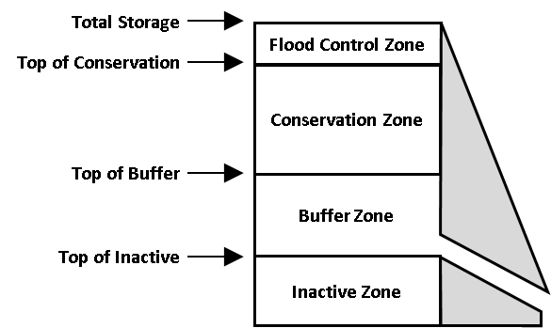
Figure 2.2 Reservoir zones in WEAP.
WEAP allows reservoirs to freely release water from the conservation pool to fully meet downstream requirements. Once the reservoir storage level drops into the buffer pool, the release is restricted according to the buffer coefficient, to conserve the reservoir’s dwindling supplies. The buffer coefficient is the fraction of the water in the buffer zone available each month for release. Thus, a coefficient close to one will cause demands to be met more fully, while rapidly emptying the buffer zone. A coefficient close to zero will leave demands unmet while preserving the storage in the buffer zone. Alternatively, the conservation zone and buffer zone may be assigned different priorities to represent changing priorities as storage reserves dwindle. Water in the inactive pool is not available for allocation, although under extreme conditions evaporation may draw the reservoir below the top of the inactive pool.

Hydrology
Although WEAP is capable of modeling hydrology inflows using catchment objects, this section has been removed for the SEWAM documentation. In SEWAM, the hydrology inflows are imported from an external model, which will be described in section 3.3.

Solution methodology
At each time step, WEAP first computes the horizontal and vertical fluxes using the catchment objects, which it passes to each river and groundwater object. Next, water allocations are made for the given time step by passing constraints related to the characteristics of reservoirs and the distribution network, environmental regulations, and the priorities and preferences assigned to demand sites to a linear programming optimization routine that maximizes demand satisfaction to the greatest extent possible (Yates, Sieber et al., 2005). All flows are assumed to occur instantaneously; thus, demand sites can withdraw water from the river, use some of the water consumptively, and optionally return the remainder to a receiving water body in the same time step. As constrained by the network topology, the model can also allocate water to meet any demand in the system, without regard to travel time. Thus, the model time step should be at least the length of the water residence time within the study area.
A form of linear programming known as mixed integer programming (MIP) is used to solve the water allocation problem whose objective is to maximize satisfaction of demand, subject to supply priorities, demand site preferences, mass balances, and other constraints. The constraint set is iteratively defined within each time step to sequentially consider the ranking of the demand priorities and supply preferences. The approach has some attributes of a more traditional dynamic programming algorithm, where the model is solved in sequence based on the knowledge of values derived from the previous variables and equations. Individual demand sites, reservoirs, and in-stream flow requirements are assigned a unique priority number, which are integers that range from 1 (highest priority) to 99 (lowest priority). Those entities with a Priority 1 ranking are members of Equity Group 1, those with a Priority 2 ranking are members of Equity Group 2, and so on. The MIP constraint set is written to supply an equal percentage of water to the members of each Equity Group. This is done by adding to the MIP for each demand site:
- A percent coverage variable, i.e., the percent of total demand satisfied at a given time step.
- An equity constraint that equally satisfies all demands within each Equity Group in terms of percentage of satisfied demand.
- A coverage constraint which ensure the appropriate amount of water supplied to a demand site or the meeting of an instream flow requirement.
The MIP is solved at least once for each Equity Group that maximizes coverage to demand sites within that Equity Group. When solving for Priority 1, WEAP will suspend (in the MIP) allocations to demands with Priority 2 and lower. Then, after Priority 1 allocations have been made that ensure equity among all Priority 1 members, Priority 2 demands are activated (but 3 and lower are still not set). Like demand priorities, supply preferences apply an integer ranking scheme to define which sources will supply a single demand site. Often, irrigation districts (ID) and municipalities will rely on multiple sources to meet their demands, so there is a need for a mechanism in the allocation scheme to handle these choices. To achieve this effect in the allocation algorithm, each supply to the same demand site is assigned a preference rank, and within the given priority, the MIP algorithm iterates across each supply preference to maximize coverage at each demand site. In addition, the user can constrain the flow through any transmission link to a maximum volume or a percent of demand, to reflect physical (e.g., pipe or pump capacities) or contractual limits, or preferences on mixing of supplies. These constraints, if they exist, are added to the MIP.
Upon solution of the MIP, the shadow prices on the equity constraints are examined and if non-zero for a demand site, then the water supplied for this demand site is optimal for the current constraint set. The supply set from the optimal solution of the current MIP, its equity constraint removed, and the LP is solved again for the current Equity Group and the equity constraints re-examined. This is repeated until the equity constraint for each demand site returns a positive shadow price, and their supplies set.
The MIP then iterates across the supply preferences, and this too is repeated until all the demand sites have an assigned water supply for the given Equity Group. The algorithm then proceeds to the next Equity Group. Once all Equity Groups are solved at the current time step, the algorithm proceeds to the next time step where time dependent demands and constraints are updated, and the procedure repeats.

Schematic and model domain
The SEWAM schematic in WEAP is a geographically based, high-resolution representation of diversion points and inflows to tributaries of SFER. This chapter provides an overview of the schematic and discusses physical elements of the model and the model’s geographic extent. Operational logic and simulation details are described in later chapters.
The development of all WEAP applications follows a standard approach. The first step in this approach is the Study Definition, wherein the spatial extent and system components of the area of interest are defined and the time horizon of the analysis is set. Subsequently, System Components (e.g., rivers, reservoirs, agricultural and urban demands) and the network configuration connecting these components are defined. Next, the model’s Current Accounts are defined to represent the system under existing conditions – including operating rules to manage both water supplies and water demands. Current Accounts serve as the point of departure for developing scenarios, which characterize alternative sets of assumptions pertaining to policies, regulatory requirements, and water infrastructure.

Study definition
The SEWAM domain, described in section 1.1 and presented previously in Figure 1.1 includes the entire SFER watershed. GIS shapefiles used in the construction of the model are stored within the SEWAM data directory and can be displayed in the model’s schematic view. The shapefiles provide visual cues in understanding and interpreting the schematic.

System component overview
The SEWAM schematic is built using components that define the water supply system and the water demands. The WEAP palette of components is shown in Figure 3.1. The following sections describe each component as it is used in SEWAM.
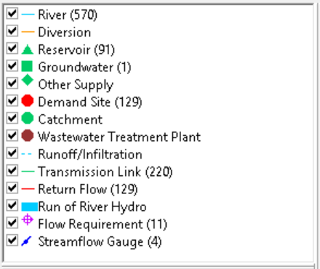
Figure 3.1 Palette of schematic components in WEAP.

Rivers
Schematic construction began with defining rivers. Shapefiles of the rivers and tributaries provided from Paradigm Environmental were traced to add these features to the WEAP schematic. Names of the tributaries came from the USGS National Map platform. Unnamed tributaries are delineated in SEWAM as “Trib_” followed by the subwatershed number.
For each of the 392 subwatersheds that feed the stream network, the hydrology is populated with three sets of daily flows- the surface water inflow, groundwater inflow, and groundwater outflow. The surface water inflows are contained within the fictitious river inflow arc object for each subwatershed. The input file in the WEAP model folder Data\Hydrology\Daily_Surface_Inflow_AF.csv contain the surface water inflows. The groundwater inflow and groundwater outflow enter the model domain in the reach of the river or tributary immediately downstream of the fictitious inflow arc in each subwatershed. The input file in the WEAP model folder Data\Hydrology\Daily_Groundwater_Exchange_AF.csv contain the groundwater inflows and outflows. The daily flows were calculated by Paradigm Environmental using the US Environmental Protection Agency’s Loading Simulation Program C (LSPC) watershed modeling system. Figure 3.2 depicts an example WEAP river schematic for a subwatershed. For the complete picture of how the hydrology flows interact with the demands in the schematic, see Figure 3.8.
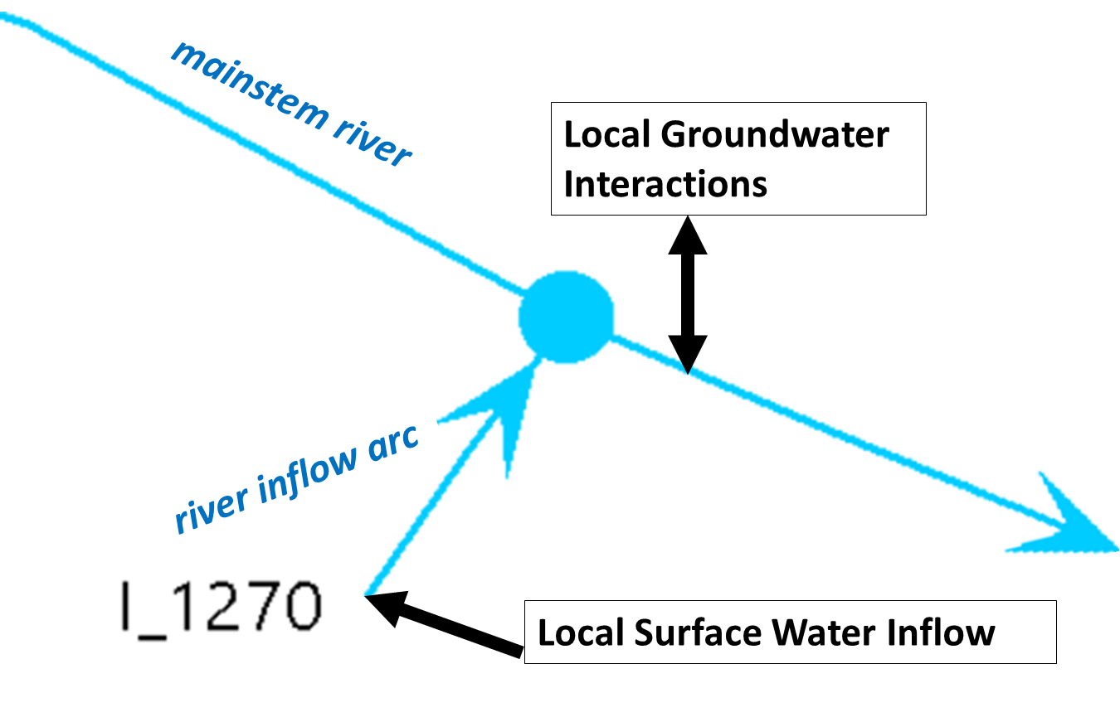
Figure 3.2 WEAP schematic with locations of local hydrology flows.

Groundwater
The SFER watershed consists of steep, rugged terrain and lacks large volumes of accessible groundwater. The water diversions in the basin are primarily surface diversions. For this reason, groundwater diversions are not explicitly represented in the WEAP schematic of SEWAM. The subwatershed groundwater inflow and outflow volumes generated from the Paradigm Environmental LSPC hydrology model have already accounted for estimates of groundwater diversions and effects of surface water-groundwater interactions. These groundwater inflows and outflows for each subwatershed are connected to a single groundwater object in WEAP, labeled “SFER GW”. While the SFER GW object enables the subwatershed hydrology to function, the groundwater storage levels should not be considered a result variable of the SEWAM model. In SEWAM, groundwater diversions that are hydrologically connected to surface water are represented as surface diversions. Other groundwater diversions are not represented in SEWAM.

Demand sites
In SEWAM, individual demand sites in the WEAP schematic are built using multiple WEAP objects to represent surface diversions for: (1) Electronic Water Rights Information Management System (eWRIMS) water right applications, (2) cannabis imagery sites, and (3) illegal domestic and DDW municipal demands. The eWRIMS database is operated by the State Water Board and contains information on registered water rights across California. Within eWRIMS, individual water rights or “applications” can refer to recent requests for a water right or established water rights. The cannabis imagery grow sites are suspected cannabis cultivation areas delineated using aerial imagery. The illegal domestic sites include existing buildings identified by imagery data which do not correspond with any eWRIMS rights. The illegal domestic demand sites are lumped together with the DDW municipal demand sites, which include two municipal service districts not permitted under eWRIMS. For more information on these demand sites and how demand volumes were estimated for SEWAM, see the Water Use Report in chapter 6.
Currently, each application within eWRIMS is represented as a single demand site while the cannabis imagery and illegal domestic demands are aggregated by subwatershed. If an application contains a diversion to storage, the demand node is paired with a reservoir object. All subwatershed demand sites for cannabis are paired with a reservoir object. The illegal domestic demand sites do not contain reservoirs. In the schematic the two objects are placed very close together, making them look like a single demand node when the schematic view is zoomed out. In the example below (Figure 3.3), the eWRIMS water application is labeled with its application ID, the cannabis imagery site is labeled with “Can_” and the subwatershed ID, and the illegal domestic demand is labeled with “ilD_” and the subwatershed ID.
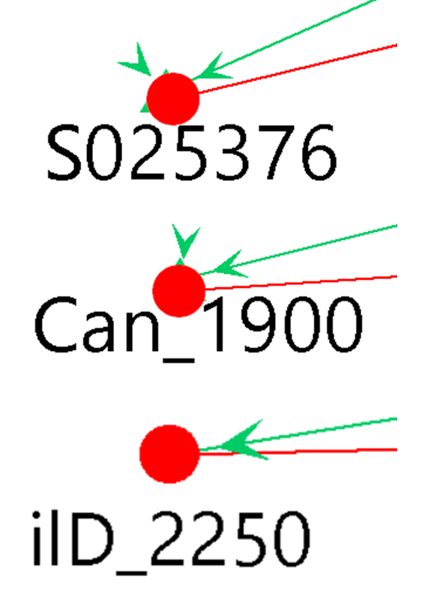
Figure 3.3 Demand sites in the WEAP schematic.
Each individual demand site that has storage objects is constructed using a group of WEAP objects as shown in Figure 3.4. However, whether or not the demand sites with reservoir objects utilize storage depends on the sensitivity scenario, described in section 5.1.
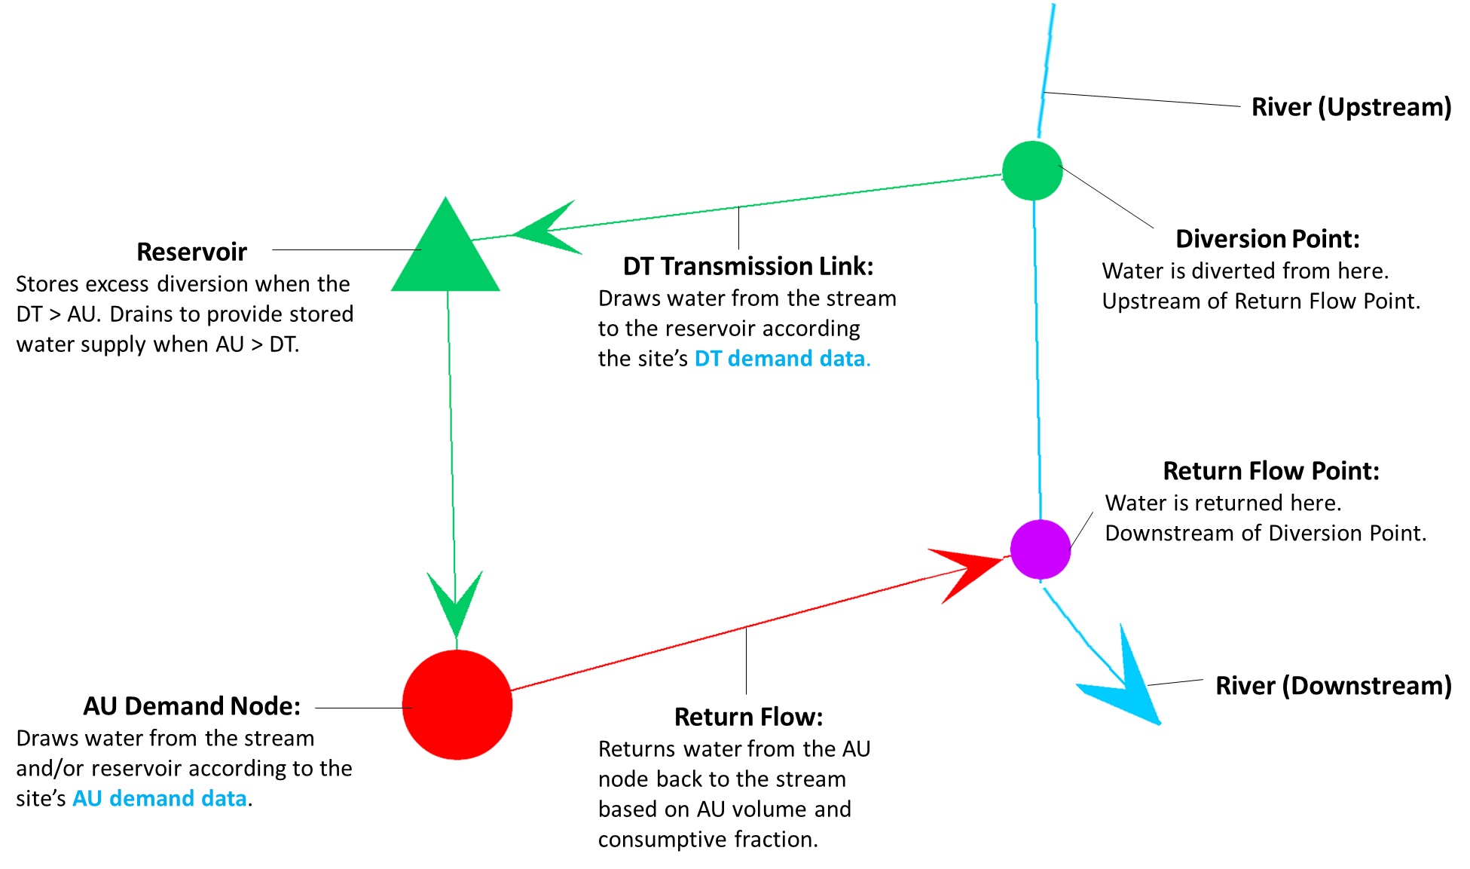
Figure 3.4 WEAP demand site components (with storage).
DT = diverted total; AU = amount used.
Each individual demand site lacking a reservoir is constructed using a group of WEAP objects as shown in in Figure 3.5.
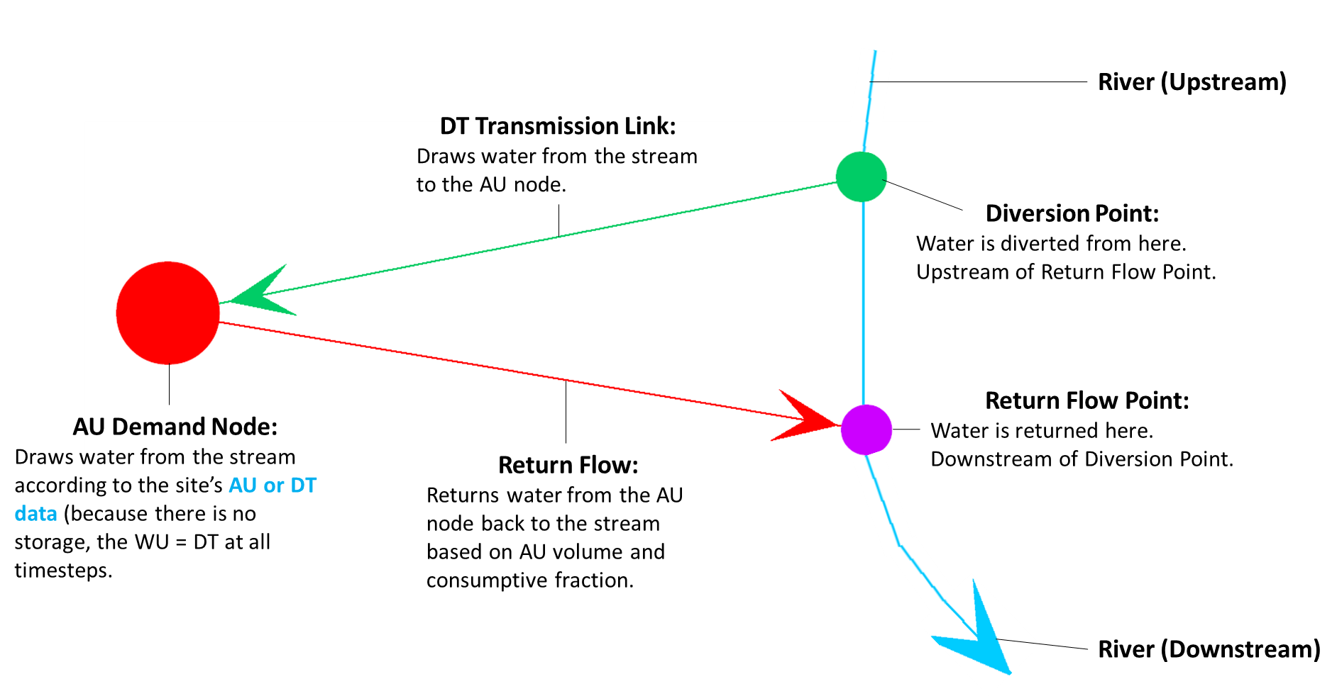
Figure 3.5 WEAP demand site components (no storage).
DT = diverted total; AU= amount used.

Transmission link objects and diversion points
Transmission links are used to connect a diversion point on the source river to a reservoir (for demand sites with storage) or to the AU (amount used) demand node of each demand site. Transmission link flows are constrained to the estimated diverted total (DT) volume for each daily timestep and determine the volume of water diverted from the river each day. The methodology for estimating the DT volume for each demand site is described in the Water Use Report in chapter 6.
The diversion point may be located at either on an inflow arc or on the mainstem in each subwatershed. An upstream diversion point is positioned on an inflow arc object and represents a diversion from a tributary within the subwatershed. A mainstem diversion point is on the stream object itself and represents a diversion from a stream depicted in the WEAP schematic. An upstream diversion point only accesses inflows originating from within the subwatershed while a mainstem diversion point has access to water flowing from upstream watersheds in addition to the subwatershed inflow. The mainstem diversion points are only present for those subwatersheds located downstream of another subwatershed. Diversion points are labeled “UD_” for upstream diversion or “MD_” for mainstem diversion, followed by the subwatershed ID (Figure 3.6).
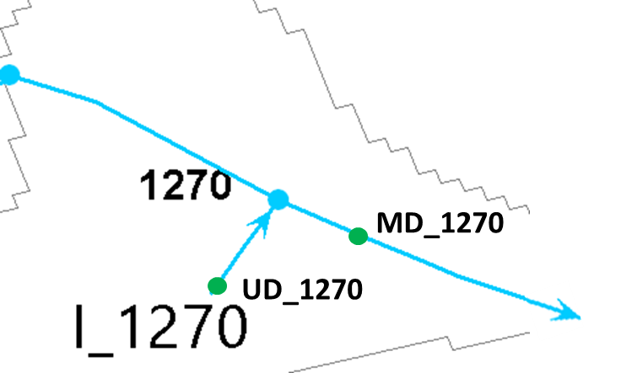
Figure 3.6 Upstream diversion (UD) and mainstem diversion (MD) points, along with local surface water inflow (I).

Demand site subwatersheds were determined first based on spatial coordinates. Then, the upstream or mainstem diversion location was chosen based on the source information of the application in eWRIMS. If the named source matched the name of the stream in the subwatershed, then the transmission link was connected to the mainstem location. All cannabis imagery and illegal domestic demand sites will connect to mainstem diversion points for all subwatersheds which contain a mainstem diversion point. For the complete picture of how the diversion points interact with the hydrology flows in the schematic, see Figure 3.8.

Amount used demand node objects
For those demand sites with storage, the AU demand node draws water from the reservoir and/or the DT transmission link object. The demand volume is set to demand site DT. When AU > DT, the AU node will pull water out of reservoir storage (if available). When DT > AU, the AU node will pull its demand from the DT Transmission link, with any excess volume going into reservoir storage.
For those demand sites without storage, the AU demand node draws water from the DT transmission link according to the DT and the AU of the application (DT and AU are equal in all time steps for these demand sites).

Reservoir objects
The SFER watershed does not contain any large in-river reservoirs. However, reservoirs are included in the model to represent water storage for eWRIMS water rights applications and cannabis imagery areas. All the cannabis imagery demand sites contain reservoir objects, while only those water rights applications with storage as recorded in eWRIMS contain reservoir objects. Reservoirs are filled from the DT volume and are drained by the AU volume described in the Water Use Report in chapter 6.

Return flow objects
In SEWAM, WEAP’s return flow arcs carry the portion of the water that is not consumed back to the source stream. Return flow arcs connect the AU demand nodes to the return points.
The return flow point may be located at either the upstream or mainstem location of each subwatershed. An upstream return flow point is positioned on the inflow arc object; a mainstem return flow point is positioned on the stream object. Both are downstream of their corresponding diversion point. Return flow points are labeled “UR_” for upstream return flow or “MR_” for mainstem return flow, followed by the subwatershed ID (Figure 3.7).
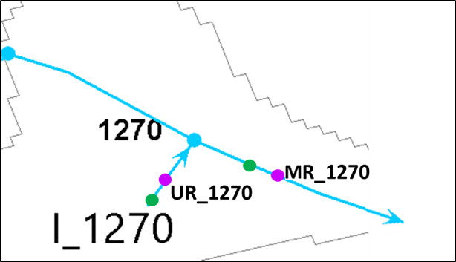
Figure 3.7 Upstream return flow (UR) and mainstem return flow (MR) points, along with local surface water inflow (I).

Figure 3.8 shows the complete schematic, with the relative locations of the return flow points, diversion points, and hydrology inflows.
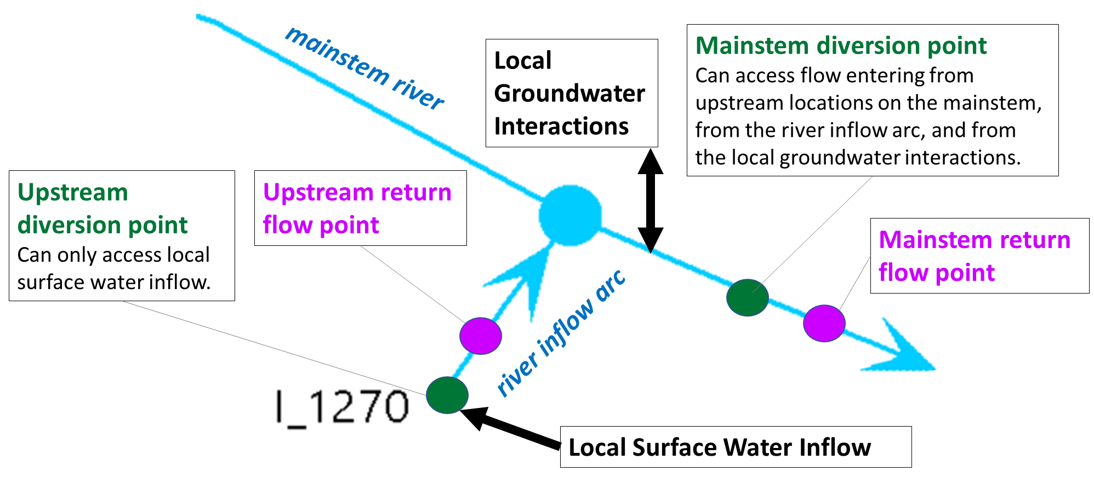
Figure 3.8 Complete WEAP schematic of diversion, return flow, and hydrology.

Flow requirements
A purple sun cross is used to represent WEAP Instream Flow Requirement objects (Figure 3.9). The flow requirement objects are labeled “IFT_” (short for instream flow target) followed by the subwatershed ID. Each flow requirement is placed at the outlet of the subwatershed in its name. The flow requirement objects compete with the demands in the water allocation algorithm, to try to maintain the minimum flow requirement instream at the object’s location. The flow requirements are populated with instream flow target data discussed in section 5.2.
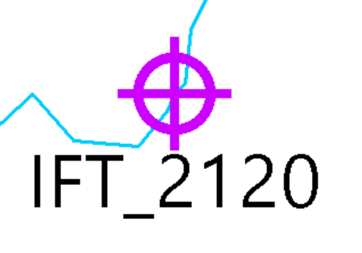
Figure 3.9 Instream flow requirement or instream flow target (IFT) object in WEAP.

Streamflow gauges
WEAP streamflow gauge objects allow rapid comparison of simulated flows to historical observed data using the WEAP results view. These gauge objects also help orient the model user in interpreting the schematic. In WEAP, streamflow gauges are represented by a blue circle with a diagonal arrow (Figure 3.10). Four gauges, containing data obtained from US Geological Survey (USGS) online resources are present in SEWAM. The gauge flow data is located in the WEAP model folder under Data\USGS Gauge Data\SFER_USGS_Flow_Data.csv.
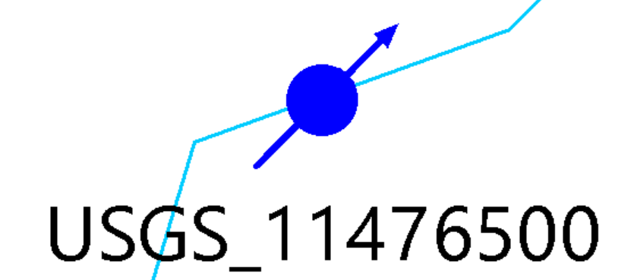
Figure 3.10 Streamflow gauge object in WEAP.

Demand site properties

Diverted total transmission links
DT transmission link objects draw water from the stream.

Maximum flow volume
For those demand sites with storage, the maximum flow volume determines the daily volume of water diversion to request from the water allocation LP.
The maximum flow volume is set to the demand site’s daily DT. The baseline daily DT, calculated according to the Water Use Report in chapter 6, may be modified according to the sensitivity scenarios discussed in section 5.1. The DT data for eWRIMS applications are read from input files in the WEAP model folder under Data\Demands of App_Daily_DT_Rep_Scn.csv for the reported water use scenario and App_Daily_DT_Per_Scn.csv for the permitted water use scenario. Cannabis imagery DT depends on the storage pattern of the sensitivity scenario and is calculated according to the cannabis storage toggle key expressions in 5.14.
For those demand sites without storage, the AU demand node, rather than the transmission link, controls the diversion volume. The maximum flow volume is left blank for these demand sites. Illegal demand sites do not have storage and thus, do not have maximum flow volume data.

Reservoirs
For those demand sites with water storage, the reservoir object represents the storage in WEAP. The reservoir receives inflow from the DT transmission link and releases flow to the AU demand node. The reservoirs are named with a suffix “_R” based on the application ID for eWRIMS applications (ie, “A123456_R”) or on the subwatershed for cannabis imagery areas (ie. “Can_1000_R”). Illegal demand sites do not have reservoir objects.

Storage capacity
The storage capacity restricts the maximum volume of water that can be stored. The storage capacity is set equal to the demand site’s annual DT. However, this is an arbitrary limit to improve model performance. Given that the annual DT for each demand site is set equal to AU, the reservoir objects will generally not reach the maximum volume and will drain the volume back down to 0 each year.

Priority date
The priority date is a user-defined variable in eWRIMS applications and appears as an 8-digit number in the form YYYYMMDD based on the application date (see section 7.3.5). The priority date is left blank for cannabis imagery and illegal domestic sites.

Priority
The priority variable determines the water allocation order for reservoir filling. For eWRIMS applications, the priority is set according to the priority date (above) using the key priority date trigger expression (see section 5.11). For cannabis imagery and illegal domestic sites, the priority is set according to key unpermitted priority expression (section 5.9).
A value of 1 is added to the expression in order to give the reservoir a lower priority than its corresponding AU demand node, allowing the reservoir to drain properly.

Amount used demand nodes
AU demand nodes drive the actual use and consumption of diverted water. For demand sites with storage, the AU demand node will draw water from the reservoir. For demand sites without storage, the AU demand node will draw water directly from the stream.

Daily demand
The daily demand determines the volume of water demanded by the AU demand node. The baseline daily AU, calculated according to the Water Use Report in chapter 6, may be modified according to the sensitivity scenarios discussed in section 5.1. The baseline AU estimates are read in from input files in the WEAP model folder under Data\Demands of App_Daily_AU_Rep_Scn.csv for eWRIMS applications in the reported water use scenario, App_Daily_AU_Per_Scn.csv for eWRIMS applications in the permitted water use scenario, Can_Daily_AU.csv for cannabis imagery areas, and ill_Daily_AU.csv for illegal domestic sites.

Consumption
The consumption variable determines the percentage of water withdrawn that is consumed rather than returned to the stream as non-consumptive use via the return flow arc. In SEWAM, the consumptive fraction for eWRIMS applications is calculated as a weighted total fraction of 0% for indoor uses and generally 80% for landscaping and economic uses (see section 7.3.2.2). The consumptive fraction is set to 80% for cannabis imagery sites (section 7.4.5) and 43% for illegal domestic sites (section 7.5.4).

Priority date
The priority date is a user-defined variable in eWRIMS applications and appears as an 8-digit number in the form YYYYMMDD based on the application date (see section 7.3.5). The priority date is left blank for cannabis imagery and illegal domestic sites.

Demand priority
The demand priority variable determines the water allocation order for meeting AU demand. For eWRIMS applications, the demand priority is set according to the priority date and the key priority date trigger expression (see section 5.11). For cannabis imagery and illegal domestic sites, the priority is set according to key unpermitted priority expression (see section 5.9).

Key expressions

Sensitivity scenario
Each individual model run of SEWAM consists of a combination of a sensitivity scenario and an instream flow target scenario. The Key\Scenarios\Sensitivity Scenario expression sets the sensitivity scenario to run, which represents options for management and sensitivity testing. The demands, storage assumptions, and priorities are all affected by the sensitivity scenario. The sensitivity scenarios run in SEWAM as of Jan 2021 are shown below in Table 5.1. Each assumption for each sensitivity scenario which deviates from the baseline assumptions is highlighted in yellow.
Table 5.1. Sensitivity scenarios run in SEWAM (as of Jan 2021).
Values highlighted in yellow represent deviations from baseline assumptions.
Sensitivity Scenarios | Cannabis Imagery Demands | Cannabis Imagery Storage | Can. & Ill. Domestic Priority | eWRIMS Demands | eWRIMS Storage
1. Baseline/Reference | 100% | None | Senior to IFR's | Permitted | On
2. Cannabis Imagery Storage (1 month) | 100% | 1 month | Senior to IFT's | Permitted | On
3. Cannabis Imagery Storage (3 months) | 100% | 3 months | Senior to IFT's | Permitted | On
4. Cannabis Imagery Storage (legal storage) | 100% | legal | Senior to IFT's | Permitted | On
5. Cannabis Imagery Demands (0x) | 0% | None | Senior to IFT's | Permitted | On
6. Cannabis Imagery Demands (2x) | 200% | None | Senior to IFT's | Permitted | On
7. Cannabis Imagery Demands (10x) | 1000% | None | Senior to IFT's | Permitted | On
8. Unpermitted Junior Priority | 100% | None | Junior to IFT's | Permitted | On
9. Reported eWRIMS Demands | 100% | None | Senior to IFT's | Reported |  | On
10. eWRIMS Storage Off | 100% | None | Senior to IFT's | Permitted |  | Off
11. All Demands Off | 0% | N/A | N/A | Off |  | N/A

Instream flow target scenario
In addition to the sensitivity scenario, each individual SEWAM model run also consists of a selection of IFT (instream flow target) scenario. The Key\Scenarios\IFT Scenario expression sets the IFT scenario to run, which populates the minimum flow requirement objects with the associated IFT. The IFT scenarios run in SEWAM as of Jan 2021 are shown below in Table 5.2. IFT input files, developed by Utah State University, UC-Davis, and the State Water Board are found in the WEAP model folder under Data\IFTs.
Table 5.2 Instream flow target scenarios in SEWAM.
# | IFT Scenario
1 | No Criteria
2 | EPP (Ecological Performance Percentile) 10%
3 | EPP 25%
4 | EPP 50%
5 | EPP 75%
6 | EPP 90%
7 | EPP Max (100%)
8 | Tessman
9 | Percent of Flow: 75
10 | Percent of Flow: 80
11 | Percent of Flow: 90
12 | Percent of Flow: 95
13 | Modified Percent of Flow
14 | North Coast IFP (Instream Flow Policy)

Cannabis demand fraction
The Key\Demands\Cannabis Demand Fraction expression scales the AU and DT demand for cannabis imagery areas relative to the baseline estimates calculated in the Water Use Report (chapter 6). The cannabis demand fraction value used in each sensitivity scenario is shown below in Table 5.3.
Table 5.3 Cannabis demand fraction values by sensitivity scenario.
Sensitivity Scenario | Cannabis Demand Fraction Value | Description
1. Baseline/Reference | 1 | Cannabis imagery DT and AU demands match baseline estimates in Water Use Report.
5. Cannabis Imagery Demands (0x) | 0 | Cannabis imagery DT and AU are set to 0.
6. Cannabis Imagery Demands (2x) | 2 | Cannabis imagery DT and AU demands are doubled relative to baseline estimates.
7. Cannabis Imagery Demands (10x) | 10 | Cannabis imagery DT and AU demands are multiplied by 10 relative to baseline estimates.
11. All Demands Off | 0 | Cannabis imagery DT and AU are set to 0.

eWRIMS demand fraction
The Key\Demands\eWRIMS Demand Fraction expression scales the AU and DT demand for eWRIMS applications relative to the baseline estimates calculated in the Water Use Report (chapter 6). The eWRIMS demand fraction value used in each sensitivity scenario is shown below in Table 5.4.
Table 5.4 eWRIMS demand fraction values by sensitivity scenario.
Sensitivity Scenario | eWRIMS Demand Fraction Value | Description
1. Baseline/Reference | 1 | eWRIMS DT and AU demands match baseline estimates in Water Use Report.
11. All Demands Off | 0 | eWRIMS DT and AU are set to 0.

eWRIMS demand scenario
The Key\Demands\eWRIMS Demand Scenario expression sets the eWRIMS demands to either use the estimates from the reported water use scenario or the permitted water use scenario (see section 7.2). The eWRIMS Demand Fraction value used in each sensitivity scenario is shown below in Table 5.5.
Table 5.5 eWRIMS demand scenario values by sensitivity scenario.
Sensitivity Scenario | eWRIMS Demand Scenario Value | Description
1. Baseline/Reference | 2 | eWRIMS DT and AU demands based on permitted water use scenario estimates from the Water Use Report.
8. Reported eWRIMS Demands | 1 | eWRIMS DT and AU demands based on reported water use scenario estimates from the Water Use Report.

Percent of flow
The Key\IFTs\Percent of Flow expression is utilized by the percent of flow IFT scenarios. The IFTs are calculated in the percent of flow IFTs scenario by multiplying the unimpaired daily streamflows by the percent of flow key expression value. The unimpaired daily streamflows are calculated from the Paradigm Environmental LSPC hydrology and represent unimpaired flows, with assumed groundwater pumping already subtracted. The streamflows are found in the WEAP model folder under Data\Hydrology\Daily_Cumulative_Flows.csv. The key percent of flow value used for the IFT scenarios is shown below in Table 5.10.
Table 5.6 Percent of flow values by IFT scenario.
Sensitivity Scenarios |  | Percent of Flow Value | Description
9. Percent of Flow: 75 | 70 |  | IFTs set to 75% of daily unimpaired* streamflow.
10. Percent of Flow: 80 | 70 |  | IFTs set to 80% of daily unimpaired* streamflow.
11. Percent of Flow: 90 | 70 |  | IFTs set to 90% of daily unimpaired* streamflow.
12. Percent of Flow: 95 | 70 |  | IFTs set to 95% of daily unimpaired* streamflow.
*Unimpaired streamflows represent unimpaired flows, with assumed groundwater pumping already subtracted

Water month type
The Key\IFTs\Water Month Type expression is utilized by the EPP IFT scenarios. The EPP scenarios set relatively higher or lower IFT values, depending on the water month type. A time-series in the WEAP model folder under Data\IFTs\Water_Month_Types.csv is populated with values based on the relative volume of monthly unimpaired inflows in the South Fork Eel River for each month from water years 1996-2019. The values, calculated by Utah State University and UC-Davis, contain the following associated descriptions in Table 5.7.
Table 5.7 Water month type descriptions
WMT Value | Description
1 | Critically Dry
2 | Dry
3 | Below Median
4 | Above Median
5 | Wet
6 | Extremely Wet

Water year type (inactive as of Jan 2021)
The Key\IFTs\Water Year Type expression was previously used by the Functional Flow Metrics IFT scenarios (no longer being run as of Jan 2021). The functional flow scenario previously set relatively higher or lower IFT values, depending on the water year type. A time-series in the WEAP model folder under Data\IFTs\Water_Year_Types.csv is populated with values based on the relative volume of annual unimpaired inflows in the South Fork Eel River for each water year from 1996-2019. The values, calculated by Utah State University and UC-Davis, contain the following associated descriptions in Table 5.8.
Table 5.8 Water year type descriptions.
WYT Value | Description
1 | Dry
2 | Moderate
3 | Wet

Unpermitted priority
The Key\Priorities\Unpermitted Priority expression determines the priority of reservoirs and demand priority of AU demand nodes for cannabis imagery and illegal domestic sites. The expression is in the form of YYYY and will set the priority of cannabis imagery and illegal domestic sites to be equivalent to that of eWRIMS applications with a priority date of that year. The unpermitted priority value used in each sensitivity scenario is shown below in Table 5.9.
Table 5.9 Unpermitted priority values by sensitivity scenario.
Sensitivity Scenario | Unpermitted Priority Value | Description
1. Baseline/Reference | 1 | Cannabis imagery and illegal domestic demands receive water allocation first and are senior to IFTs and eWRIMS demands.
8. Unpermitted Junior Priority | 1 | Cannabis imagery and illegal domestic demands receive water allocation last and are junior to IFTs and eWRIMS demands.

Flow requirement priority
The Key\Priorities\Flow Req Priority expression determines the priority of the minimum flow requirement objects. The expression is in the form of YYYY and will set the priority of cannabis imagery and illegal domestic areas to be equivalent to that of eWRIMS applications with a priority date of that year. The baseline value is 2 and does not change under sensitivity scenarios.

Priority date trigger
The Key\Priorities\Priority Date Trigger expression changes the resolution of the priority date that is used to determine the priority of reservoirs and demand priority of AU demand nodes for eWRIMS applications. The coarser trigger values (such as 100 000 for decade) have faster run time; the finer trigger values (such as 1 for day) are more precise. An example of priority under different values of priority date trigger is shown in Table 5.10. As of Jan 2021, SEWAM uses a value of 10,000, corresponding to a yearly resolution.
Table 5.10 Priority date trigger values and corresponding demand priorities for 25 January 1914.
Trigger value | Resolution | Priority
1 | Day | 191401250
100 | Month | 191401000
10 000 | Year | 191400000
100 000 | Decade | 191000000

Use type distribution orders (inactive as of Jan 2021)
The Key\Priorities\Use Type Distribution Orders expressions are inactive in SEWAM as of Jan 2021 and do not affect the model results.

eWRIMS Storage Toggle
The Key\Storage\eWRIMS Storage Toggle expression determines if eWRIMS demands are able to utilize any estimated on-site storage in SEWAM. Note that not every eWRIMS application has estimated on-site storage. The eWRIMS storage toggle value used in each sensitivity scenario is shown below in Table 5.11. When the on-site storage is inactive, eWRIMS demands match the DT to the AU data, meaning the water is diverted and used in the same timestep.
Table 5.11 eWRIMS storage toggle values by sensitivity scenario.
Sensitivity Scenario | eWRIMS Storage Toggle Value | Description
1. Baseline/Reference | 1 | Any eWRIMS on-site storage set as active.
10. eWRIMS Storage Off | 0 | eWRIMS on-site storage set as inactive.

Cannabis Storage Toggles
The Key\Storage\Cannabis Storage Toggles key expression folder determines the storage pattern of cannabis imagery sites. The primary key expression is Cannabis Storage Option Adjustment, which ranges from 0-1. The current value used in each sensitivity scenario is seen below in Table 5.12. A more detailed explanation of these storage patterns is found in section 7.4.4.
Table 5.12 Cannabis storage option adjustment value by sensitivity scenario.
Sensitivity Scenario | Cannabis Storage Option Adjustment Value | Description
1. Baseline/Reference | 0 | Cannabis imagery on-site storage set inactive.  DT = AU.
2. Cannabis Imagery Storage (1 month) | 0.22 | Cannabis imagery on-site storage may reach a maximum volume equal to the highest 1 month of AU demands.  DT = 1 month storage pattern (see section 7.4.4)
3. Cannabis Imagery Storage (3 months) | 0.6 | Cannabis imagery on-site storage may reach a maximum volume equal to the highest 3 months of AU demands.  DT = 3 month storage pattern (see section 7.4.4)
4. Cannabis Imagery Storage (legal storage) | 1 | Cannabis imagery sites may only divert from Nov-Mar and must store water for use during other months.  DT = Legal storage pattern (see section 7.4.4).

The cannabis storage option adjustment calculates the DT monthly distribution in the model by setting the weight of 2 different DT patterns. The DT patterns to draw from can be changed by modifying the Cannabis Storage Option 1 Toggle and Cannabis Storage Option 2 Toggle expressions. As the cannabis storage option adjustment approaches 0, the option 1 DT monthly distribution will be weighted more heavily. On the other hand, as the cannabis storage option adjustment approaches 1, the option 2 DT monthly distribution will be weighted more heavily. The cannabis storage options currently built into SEWAM are shown below in Table 5.13.
Table 5.13.Cannabis storage option toggles.
Cannabis Storage Option 1/2 Toggle Value | Description
1 | No storage.  Cannabis imagery DT monthly distribution set to AU monthly distribution (see section 7.4.4).  Current value of option 1 toggle in SEWAM.
2 | North Coast Storage.  Cannabis imagery DT monthly distribution set to average DT distribution calculated from NC RWQCB 2017 dataset.  Not currently used in SEWAM.
3 | No storage.  Cannabis imagery DT monthly distribution spread out from Nov-Mar (see section 7.4.4).  Current value of option 2 toggle in SEWAM.

Model Results
This section describes the main results contained within the SEWAM model. In WEAP, the main results have been saved under result favorites. The demand results are currently aggregated by subwatershed. However, it is possible to adjust the run settings of SEWAM so that results of individual demand sites may be viewed as well.
The results of SEWAM however, have largely been viewed through the use of a Tableau Software visualization tool. Instructions on navigating the Tableau visualization are contained within the Tableau workbook itself and are not discussed in this document.

Diverted total result favorites
There are a total of 18 result favorites describing the DT results in WEAP for SEWAM. Each of the 18 result favorites is comprised of a combination of one result variable, demand type, and areas, as shown in Table 6.1. For each of these favorites, the results contain flows aggregated across each subwatershed.
Table 6.1 Diverted total result combination components
Each result favorite saved in WEAP is a combination built from one component from each column.
1. Result Variables | 2. Demand Types | 3. Areas
DT Potential | Cannabis Imagery (Can) | Contributing Area (CA)
DT Supplied | eWRIMS (eWR) | Intermediate Area (INT)
 | Illegal Domestic (IlD) | Local Subwatershed (Local)
While the demand types refer to the cannabis imagery, eWRIMS, and illegal domestic demands, as covered in chapter 7, the result variables and area terms in Table 6.1 are defined below:
Result Variables:
- DT Potential:
  - Refers to the flow of water requested to be diverted out of the stream via the DT transmission link of each demand site (see Figure 3.4 and Figure 3.5). Represents the potential DT that would be delivered if all demands are met.
- DT Supplied
  - Refers to the flow of water supplied and diverted out of the stream via the DT transmission link of each demand site (see Figure 3.4 and Figure 3.5). Represents the DT that is actually supplied in the model allocation, taking into account modeled water shortages.

Areas (see Figure 6.1):
- Contributing Area (CA):
  - Encompasses demands within all subwatersheds in the contributing area of and which drain to the specified subwatershed (including the specified subwatershed itself).
- Intermediate Area (INT):
  - Encompasses demands within the set of subwatersheds which drain to the flow requirement in the specified subwatershed (including the specified subwatershed itself) before draining to any other flow requirement. Is calculated only for subwatersheds which have flow requirements.
- Local Subwatershed (Local):
  - Encompasses demands only within the specified subwatershed.
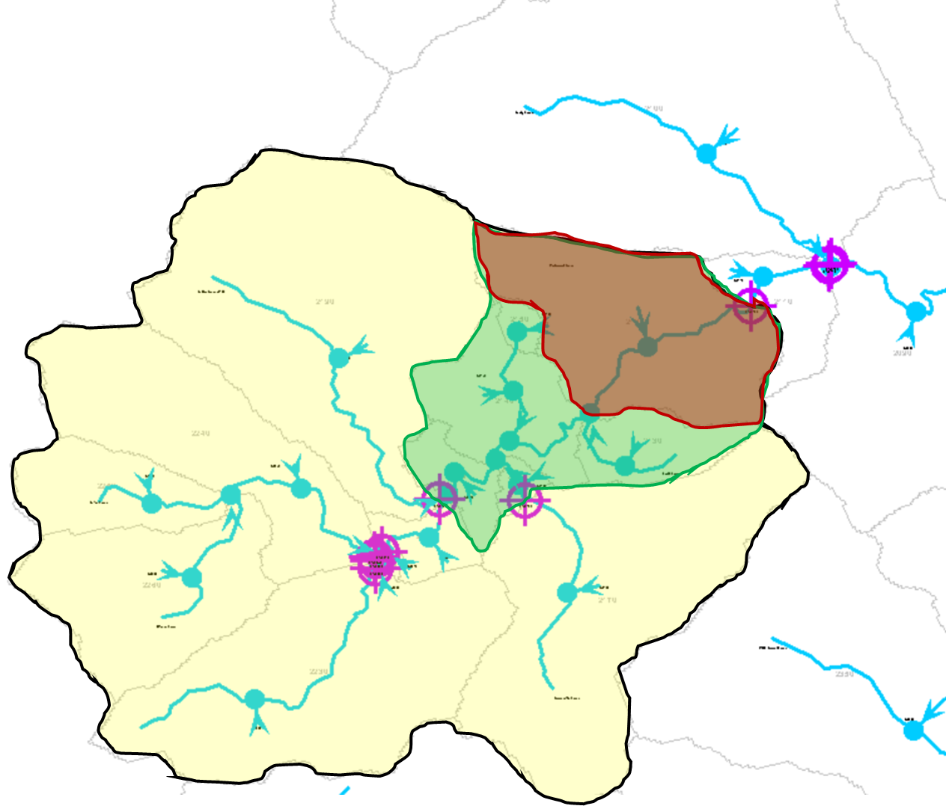
Figure 6.1 Example Contributing Area, Intermediate Area, and Local Subwatershed
Key: Yellow = Contributing Area, Green = Intermediate Area, Red = Local Subwatershed
Each favorite in WEAP is named with a concatenation of the terms in Table 6.1. The full list of the diverted total favorites is found below. Each
- DT_Potential_Can_CA
- DT_Potential_Can_INT
- DT_Potential_Can_Local
- DT_Potential_eWR_CA
- DT_Potential_eWR_INT
- DT_Potential_eWR_Local
- DT_Potential_IlD_CA
- DT_Potential_IlD_INT
- DT_Potential_Ild_Local
- DT_Supplied_Can_CA
- DT_Supplied_Can_INT
- DT_Supplied_Can_Local
- DT_Supplied_eWR_CA
- DT_Supplied_eWR_INT
- DT_Supplied_eWR_Local
- DT_Supplied_IlD_CA
- DT_Supplied_IlD_INT
- DT_Supplied_ILD_Local

Flow requirement and streamflow results
In SEWAM in WEAP, there are also several result favorites related to the flow requirements and streamflow. These result favorites are described below.
- Flow Requirement Coverage:
  - Contains the coverage of each instream flow requirement object. Coverage ranges from 0-100% and is defined as the streamflow ÷ instream flow requirement.
- Instream Flow Requirement:
  - Contains the minimum flow requested by each flow requirement object in cfs.
- Streamflow:
  - Contains the modeled streamflow at each location. The default setting is to only show the streamflow at the instream flow requirement locations .
- Unmet Flow Requirement
  - Contains any flow requested by the flow requirement objects which was not met. Calculated as instream flow requirement – streamflow (minimum value of 0).

Water Use Report
The text of this chapter first appeared in the South Fork Eel River Water Use Report documentation, prepared for the State Water Resources Control Board. The version presented has been last updated December 2020. Portions of this chapter also appear in chapter 1 of this document.
Minor edits have been made for consistency with the rest of this document.

South Fork Eel River Water Use Report
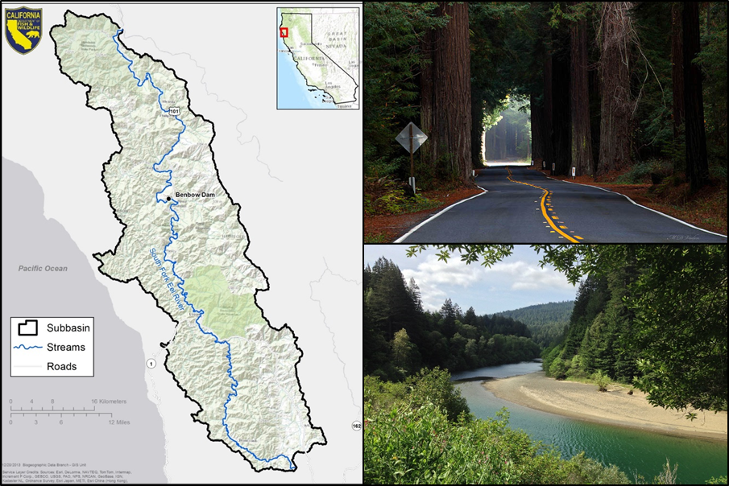
Image Sources (clockwise from left: CDFW, 2018; M.D. Vaden; Wikimedia Commons

Doug Chalmers- Stockholm Environment Institute
January 2019

Updated December 2020

Introduction
The following description of the WEAP and the SFER project also appears in chapter 1 of this document.
The California Natural Resources Agency, the California Environmental Protection Agency, and the California Department of Food and Agriculture developed the California Water Action Plan (WAP), released on January 22, 2014. The WAP has been developed to meet three broad objectives:
More reliable water supplies;
The restoration of important species and habitat; and
A more resilient, sustainably managed water resources system (water supply, water quality, flood protection, and environment) that can better withstand inevitable and unforeseen pressures in the coming decades.
Action Four of the WAP, to “Protect and Restore Important Ecosystems,” contains a sub-action that states the following:
The State Water Resources Control Board and the Department of Fish and Wildlife will implement a suite of individual and coordinated administrative efforts to enhance flows statewide in at least five stream systems that support critical habitat for anadromous fish. These actions include developing defensible, cost-effective, and time-sensitive approaches to establish instream flows using sound science and a transparent public process. When developing and implementing this action, the State Water Resources Control Board and the Department of Fish and Wildlife will consider their public trust responsibility and existing statutory authorities such as maintaining fish in good condition.
Through a coordinated effort between the State Water Resources Control Board (State Water Board) and California Department of Fish and Wildlife (CDFW), the following stream systems have been identified as a starting point for the WAP effort:
Shasta River, tributary to the Klamath River, Siskiyou County
South Fork Eel River, tributary to the Eel River, Humboldt and Mendocino Counties
Mark West Creek, tributary to the Russian River, Sonoma County
Mill Creek, tributary to the Sacramento River, Shasta and Tehama Counties
Ventura River, Santa Barbara and Ventura Counties
The State Water Board and CDFW are currently working to identify potential actions that may be taken to enhance and establish instream flow for anadromous fish in these five priority streams and other streams of importance to the WAP objectives.
The development of water allocation models will enable the State Water Board to evaluate the impact of instream flow policy options on water supply users. A critical step in developing a water allocation model is to estimate water use patterns in the subject watershed.
This document specifically focuses on the South Fork Eel River (SFER) watershed, and describes the approach taken to estimate water use patterns there.

Background
The SFER watershed (Figure 7.1) encompasses 683 square miles (CDFW, 2018) in Mendocino County and Humboldt County, approximately 150 miles north of San Francisco, California. The river originates in the Coastal Range mountains and converges with the mainstem Eel River before draining to the Pacific Ocean. Populations of coho salmon, Chinook salmon, and steelhead trout that inhabit the river are currently threatened by periods of low flow during the dry summer months (CDFW, 2018). Natural low-flow periods in the basin are exacerbated by human development and diversions.
Since the legalization of recreational cannabis in California in 2016, the State Water Board reports that “cultivation of the crop has expanded dramatically…and is associated with increased water diversions” in the SFER (Shields, 2018).
Figure 7.1 Map of the South Fork Eel River watershed
Source: (CDFW, 2018).
SEI has constructed a water allocation model to evaluate potential water supply impacts from various instream flow policy scenarios. Among other features, the water allocation model will represent all water rights in the SFER watershed, as documented in the State Water Board’s Electronic Water Rights Information Management System (eWRIMS) database. eWRIMS is a computer database developed by the State Water Board to track information on water rights in California (State Water Board, 2018). SEI has used their own tool, called the eWRIMS Analyzer, to process the water rights data to produce the calculations in this chapter.
In addition to describing the water use estimates for the eWRIMS applications (section 7.3), this document describes the water use estimates outside of eWRIMS. These sources include cannabis imagery cultivation, illegal domestic, and Department of Drinking Water (DDW) municipal demands. The cannabis imagery (section 7.3.5) cultivation sites describe those cannabis cultivation sites which are identified using aerial imagery analysis in the watershed. The illegal domestic sites (section 7.5) describe household water use for buildings in the watershed not included within an eWRIMS application or municipal water service area. The DDW municipal demands (section 7.6) include municipal water use for service areas not included in eWRIMS.
In the following descriptions of eWRIMS estimates, individual water rights are referred to as “applications” as the Application ID Number is the primary identifier used for tracking water rights in eWRIMS. The term “application” refers to the fact that water rights are initiated by the submission of a water right application to the State Water Board. An Application ID Number is assigned by the State Water Board upon acceptance of the water right application.
Each application may contain Water Use Reports. Water use reports are self-reported by the water right holder. The eWRIMS database contains annual Water Use Reports for the years 2009-2017 (as of January 2019). However, Water Use Reports are not present for every application, and not every application contains Water Use Reports for every year. Water use reports ideally contain the following data:
Diversion to Storage: The amount of water that is diverted from a stream into storage (ie. Tanks or reservoirs).
Direct Diversion: The amount of water diverted from a stream that is directly used or applied (No storage).
Diverted Total (DT): The sum of the direct diversion volumes and diversion to storage volumes.
Amount Used (AU): The amount of water used that has been held in storage and/or from direct diversion.
The water allocation model utilizes the DT and AU values most prominently, with the terms being similarly applied to the demands from outside of eWRIMS as well. The distinction between DT and AU is important because the timing of each may differ throughout the year. Applications in the SFER watershed commonly have diversion to storage during the wet winter months, while AU may largely occur during the warm, dry summer months as the stored water is used.
Applications documented in eWRIMS have varying levels of detail. Appropriative rights document the permitted diversion limits and permitted season of diversion. Other application types, typically riparian and pre-1914 rights, do not have permitted diversion limits. Some applications include several years of Water Use Reports while others contain only initial statements of reported use. Since a goal for the water allocation model is to represent all applications in the watershed, a method is needed to estimate the monthly DT and AU for each application.
Similarly for the demands outside of eWRIMS, a method is needed to estimate the monthly DT and AU for each demand site. Methodology based on available reported data for cannabis water use was applied to generate DT and AU estimates for the cannabis imagery. Methodology based on reported domestic water use were applied to generate DT and AU estimates for the illegal demand and DDW municipal demand sites.
This document discusses the approach and assumptions used to estimate monthly DT and AU for every demand site in the SFER watershed. Specifically, the following are addressed:
- How eWRIMS DT and AU were estimated for two simulation scenarios, the reported water use scenario and permitted water use scenario (section 7.3).
- How water rights applications were classified into beneficial use (BU) groups. (section 7.3.3).
- How cannabis imagery DT and AU were estimated under varying storage assumptions (section 7.3.5).
- How illegal domestic DT and AU were estimated (section 7.5).
- Municipal DDW DT and AU were estimated (section 7.6).
- How consumptive fractions were calculated for each demand site.

Simulation scenarios
Data sets for two simulation scenarios have been developed for use in the water allocation model. The reported water use scenario is based on actual reported values provided by the water rights holders. The permitted water use scenario is based on the maximum permitted DT (defined and discussed in more detail in section 7.3). The estimates for illegal domestic and DDW municipal demands are the same in each scenario. The estimates for cannabis imagery demands are the same within the simulation scenarios of reported and permitted water use, but the monthly timing of diversions throughout the year varies according to the storage assumptions, as discussed in section 7.4.4.
Analysis shown in

Figure 7.2 and Table 7.3 indicates that basin-wide DT is similar for the two scenarios from July to November, while it is significantly higher for the permitted water use scenario from December to June. This implies that many eWRIMS applications are diverting near their legal allowed limit in the summer months, but not during other months. The estimates for cannabis imagery (using the 1-month storage pattern, as discussed in section 7.3.5), illegal domestic, and DDW municipal demands are included within these figures.

Figure 7.3 breaks out the basin-wide DT estimates into the individual demand components. The individual demand components are listed in Table 7.2 for the reported water use scenario and Table 7.3 for the permitted water use scenario.

Figure 7.2 Reported and permitted water use scenario basin-wide diverted total.

Table 7.1 Reported and permitted water use scenario basin-wide diverted total.
Scenario | Annual | Oct | Nov | Dec | Jan | Feb | Mar | Apr | May | Jun | Jul | Aug | Sep
Reported | 5007 | 385 | 570 | 305 | 354 | 337 | 341 | 275 | 336 | 482 | 557 | 582 | 482
Permitted | 7247 | 468 | 595 | 597 | 624 | 583 | 631 | 366 | 671 | 807 | 626 | 686 | 595
All estimates in AF

Figure 7.3 Basin-wide diverted total estimates.

Table 7.2 Reported water use scenario basin-wide diverted total (AF).
 | Annual | Oct | Nov | Dec | Jan | Feb | Mar | Apr | May | Jun | Jul | Aug | Sep
eWRIMS (Rep Scn) | 3713 | 282 | 497 | 231 | 284 | 271 | 267 | 225 | 240 | 333 | 376 | 384 | 324
Cannabis Imagery (1-month storage) | 849 | 67 | 51 | 43 | 43 | 43 | 45 | 17 | 50 | 102 | 126 | 147 | 115
Illegal Domestic | 374 | 30 | 19 | 26 | 22 | 19 | 22 | 26 | 37 | 41 | 49 | 45 | 37
Municipal DDW | 71 | 5 | 4 | 5 | 6 | 5 | 7 | 7 | 8 | 6 | 7 | 6 | 6
Total | 5007 | 385 | 570 | 305 | 354 | 337 | 341 | 275 | 336 | 482 | 557 | 582 | 482

Table 7.3 Permitted water use scenario basin-wide diverted total (AF).
 | Annual | Oct | Nov | Dec | Jan | Feb | Mar | Apr | May | Jun | Jul | Aug | Sep
eWRIMS (Per Scn) | 5954 | 366 | 521 | 523 | 553 | 516 | 556 | 315 | 575 | 658 | 445 | 488 | 437
Cannabis Imagery (1-month storage) | 849 | 67 | 51 | 43 | 43 | 43 | 45 | 17 | 50 | 102 | 126 | 147 | 115
Illegal Domestic | 374 | 30 | 19 | 26 | 22 | 19 | 22 | 26 | 37 | 41 | 49 | 45 | 37
Municipal DDW | 71 | 5 | 4 | 5 | 6 | 5 | 7 | 7 | 8 | 6 | 7 | 6 | 6
Total | 7247 | 468 | 595 | 597 | 624 | 583 | 631 | 366 | 671 | 807 | 626 | 686 | 595

The annual DT, defined as the total volume diverted in a single year, by subwatershed is shown for the reported water use scenario in Figure 7.4 and the permitted water use scenario in Figure 7.5. The estimates for cannabis imagery (with 1-month storage pattern), illegal domestic, and DDW municipal demands are included within these figures.
Figure 7.4 Reported water use scenario: diverted total by subwatershed.
Figure 7.5 Permitted water use scenario: diverted total by subwatershed.
Creating a complete set of DT and AU for each scenario, in which every demand site has both reported and permitted monthly values, is challenging due to data inconsistencies and data gaps. Several assumptions had to be made in order to fill the data gaps. The assumptions made for creating water use estimates are described in section 7.3 for eWRIMS applications, section 7.3.5 for cannabis imagery, and section 7.5 for illegal domestic and section 7.6 for DDW municipal demands.

eWRIMS applications demand estimates
The largest source of demand estimates in SEWAM originate from the water rights applications contained in the eWRIMS database. A set of methods was developed to generate monthly estimates of DT and AU for both the reported and permitted water use scenarios, despite that the water rights contain inconsistent types of data. These methods for generating the eWRIMS water use estimates is described in the following section.

Estimating eWRIMS diverted total
The Diverted Total (DT) value is the sum of diversions to storage and direct diversions. The diversions to storage are typically winter month diversions that are used to fill ponds and water tanks. Direct diversions are made throughout the year. Definitions used in this section include:
Face Value: A value in the eWRIMS database that represents a maximum permitted annual diversion for an individual application.
Allowed DT: An alternate value that represents a maximum permitted annual diversion for an individual application that has been calculated in this analysis based on values found in eWRIMS. The Allowed DT is calculated by multiplying the maximum diversion rate by the allowed diversion period, then adding this number to the allowed maximum diversion to storage.
Permitted DT: Permitted DT is the maximum permitted annual diversion for each application. When an application includes a Face Value, the Permitted DT is equal to the Face Value. When an application does not contain a Face Value, the Permitted DT is equal to the Allowed DT.
Initial Statement of Diversion and Use (Initial Statement): When a water rights holder first claims a riparian or pre-1914 water right, they must submit an Initial Statement containing reported DT values. For those applications that do not have any annual Water Use Reports, State Water Board staff located Initial Statements, if available, to provide supplemental data. In some cases, Initial Statements are filed by a water user prior to applying for an appropriative water right.
Annual Water Use Report (Water Use Report): A Water Use Report declares how much water was diverted, stored, and used in a given year for a particular application. Water Use Report is a general term that encompasses Supplemental Statements of Diversion and Use (in the case of riparian and pre-1914 water rights), Reports of Licensee (in the case of licensed appropriative water rights), and Reports of Registrant (in the case of registrations).
BU (Beneficial Use) Group: When applying for a water rights application, the user must specify one or more BUs that describe the purpose of the diversion. The BU Groups defined in this analysis (discussed in section 7.3.3) include Cannabis (Permitted), Domestic, Irrigation, Municipal, Recreation, Stockwatering, and Other.
Average Ratios of Reported DT: Face Value (Rep:FV Ratio): Not every water user reports using the full amount of their permitted water volumes (face value) every year. It is useful to understand how much of the face value is being used, on average, for water users in each BU Group. The Rep:FV Ratio (discussed in more detail in section 7.3.4.4) is used in the reported water use scenario for applications that have an assigned Face Value, but contain no Water Use Reports. For these applications, the face value is scaled down by the Rep:FV Ratio to obtain an estimated DT value.

Reported water use scenario diverted total logic tree
The logic tree for generating the monthly DT values for each eWRIMS application in the reported water use scenario is shown below in Figure 7.6. A description of each branch of the logic tree is provided after the figure.

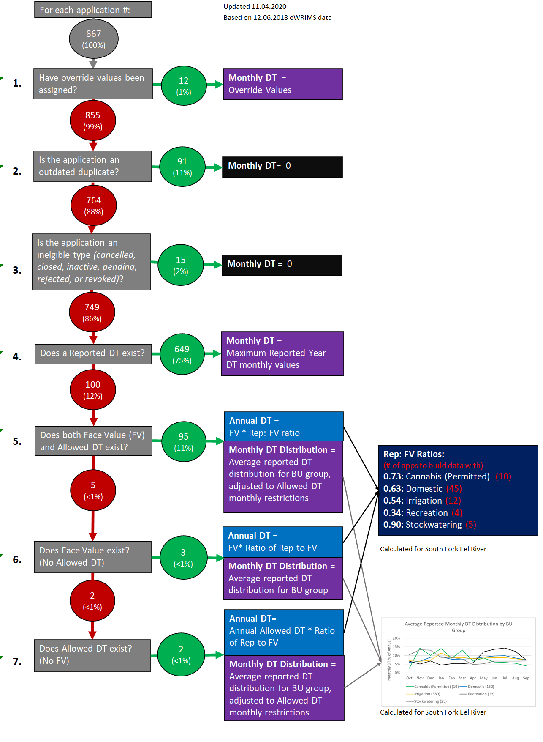
Figure 7.6 Reported water use scenario diverted total eWRIMS logic tree.
Red circles represent the applications considered in each question. Green circles represent the applications meeting the criteria of the question.
The analysis performed at each step of the reported water use scenario DT logic tree is described below.
- Override Values (1%)
For special cases of applications containing data that does not reflect their current use, override values of DT were entered in the eWRIMS Analyzer and used in place of the eWRIMS data.
- Outdated Duplicates (11%)
  - A duplicate analysis revealed many instances of statement of use water rights that have since transitioned into becoming a permanent registration application (see duplicates logic tree). In order to not double-count these water rights, the reported data from the statement was migrated to the registration application and the DT of the statement was then set to 0.
- Ineligible Application Types (2%)
  - While present in the eWRIMS database, applications that were cancelled, closed, inactive, pending, rejected, or revoked reflect no current diversions and were set to 0.
- Reported DT (75%)
  - The reported DT data of the applications contain monthly diversion values. This data comes from the water use report of eWRIMS, if present, or the initial statements associated with the application. If an application had reports for multiple years, the year with the highest annual DT was used as a conservative estimate of DT.
- Face Value and Allowed DT (11%)
  - For those applications with no water use reports or initial statements, Face Value and Allowed DT were used to estimate diversions instead. For those applications that had both a Face Value and Allowed DT, the annual diversion total is set to the Face Value multiplied by the Rep: FV ratio of the BU group (discussed in section 3.4). These ratios were used to estimate the average proportion of the Face Value that is typically utilized by each application within the BU group. The monthly distribution was set to the average reported DT distribution of the BU group, adjusted according to the allowed dates specified in the Allowed DT. If the average reported DT distribution of the BU group multiplied by the Face Value and the ratio exceeds the Allowed DT for any month, the month’s DT was set to the Allowed DT instead. The remainder from this process was distributed among the other months proportionately according to the average reported DT distribution of the BU group.
- Face Value only (<1%)
  - There were only 3 applications that had a Face Value, but did not have an Allowed DT or reported values. For these applications, the Face Value was used as the annual DT and the monthly distribution was set to the average reported DT distribution of the BU group (no Allowed DT data was available to adjust this distribution).
- Allowed DT only (<1%)
  - There were only 2 applications that had a Permitted DT, but did not have a Face Value. For these applications a similar process as Step 5 was performed, only with the annual Allowed DT substituting for the Face Value. The annual DT was set to the Allowed DT multiplied by the Reported to Face Value ratio of the BU group. The monthly distribution was set to the average reported DT distribution of the BU group, adjusted according to the allowed dates specified in the Allowed DT.
Figure 7.7 shows the monthly DT values for each eWRIMS data source for the reported water use scenario of each data source. This figure indicates that nearly all DT represented in the reported water use scenario is calculated from Reported DT.

Figure 7.7 Monthly eWRIMS diverted total by data source for reported water use scenario.

Permitted water use scenario diverted total logic tree
The logic tree for generating the monthly DT values for each eWRIMS application in the permitted water use scenario is shown in Figure 7.8. A description of each branch of the logic tree is provided after the figure.
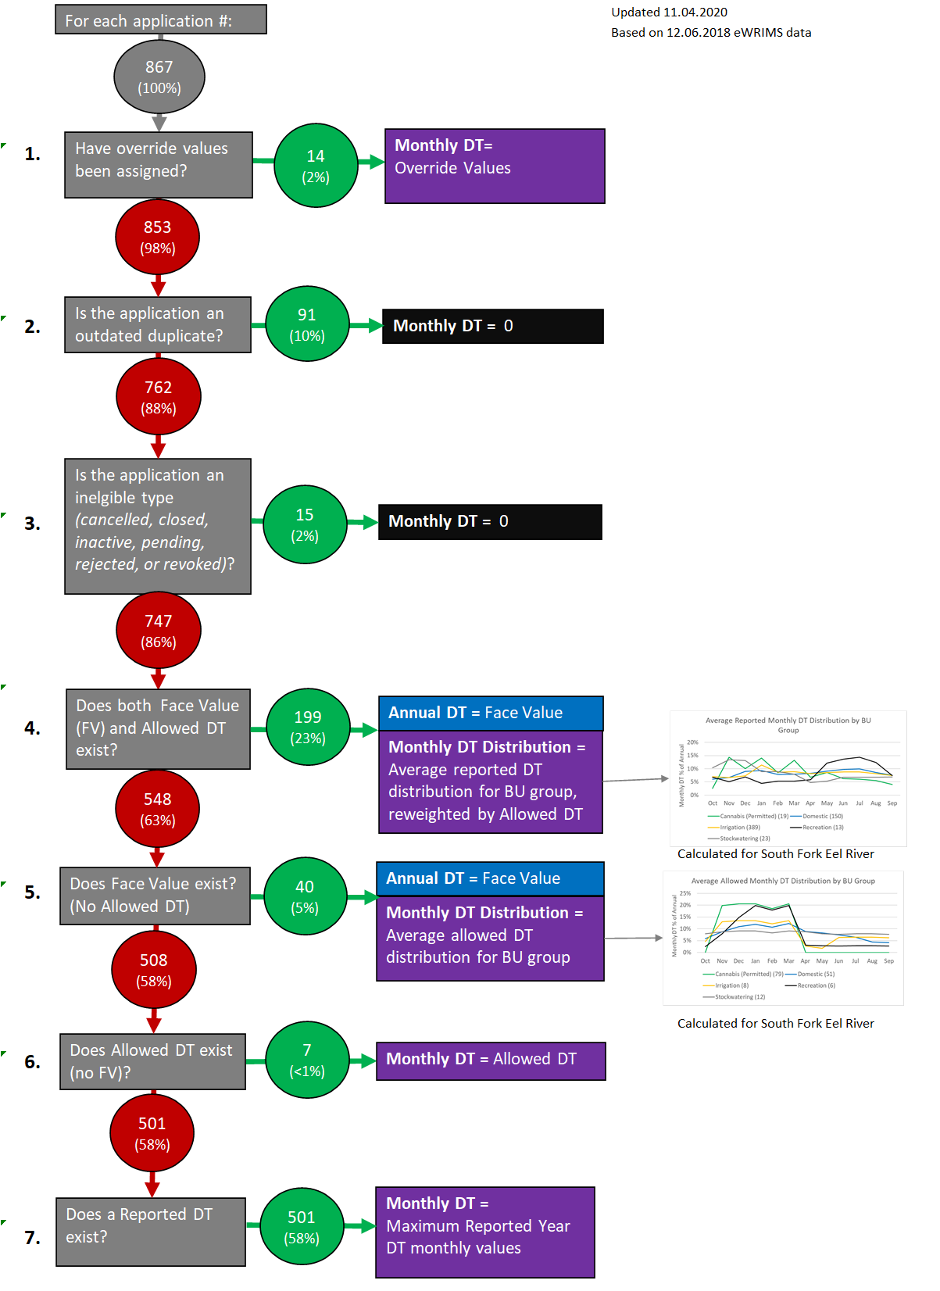
Figure 7.8 Permitted water use scenario diverted total eWRIMS logic tree.
Red circles represent the applications considered in each question. Green circles represent the applications meeting the criteria of the question.
The analysis performed at each step of the permitted water use scenario DT logic tree is described below.
- Override Values (2%)
  - For special cases of applications containing data that does not reflect their current use, override values of DT were entered in the eWRIMS Analyzer and used in place of the eWRIMS data.
- Outdated Duplicates (10%)
  - A duplicate analysis revealed many instances of statement of use water rights that have since transitioned into becoming a permanent registration application (see duplicates logic tree). In order to not double-count these water rights, the reported data from the statement was migrated to the registration application and the DT of the statement was then set to 0.
- Ineligible Application Types (2%)
  - While present in the eWRIMS database, applications that were cancelled, closed, inactive, pending, rejected, or revoked reflect no current diversions and were set to 0.
- Face Value and Allowed DT (23%)
  - For those applications that had both a Face Value and Allowed DT, the annual DT was set to the Face Value. The Face Value may be lower than the annual Allowed DT. This means that the water rights holder exceeds their Face Value if they divert their maximum monthly allowed DT for every month. The monthly distribution was set to the average reported DT distribution of the BU group, adjusted according to the allowed dates specified in the Allowed DT. If the average reported DT distribution of the BU group multiplied by the Face Value exceeded the Allowed DT for any month, the month’s DT was set to the Allowed DT instead. The remainder from this process was distributed among the other months proportionately according to the average reported DT distribution of the BU group. The average reported monthly DT distribution was used for this purpose because it more closely reflects when the users desire to divert the water. The average allowed monthly DT distribution was not used here because it more closely reflects the allowed DT dates for a given BU group, which is data already present for these applications.
- Face Value only (5%)
  - For those applications with a Face Value, but not an Allowed DT, the annual DT was set to the Face Value. Since the Face Value does not contain any data on the timing of the water use, the monthly distribution was set to the average allowed DT monthly distribution for the BU group.
- Allowed DT only (<1%)
  - For those applications an Allowed DT, but no Face Value, the monthly DT values were set to the monthly Allowed DT values.
- Reported DT (58%)
  - Applications classified as Statement of Use did not contain Face Value or Allowed DT data. Therefore, even in the Permitted Scenario, 58% of applications still used the reported DT from the water use reports, if present, or the initial statement to represent the diversion. The reported values represent the reported diverted total data of the application. If an application had reports for multiple years, the year with the largest annual DT was used as a conservative estimate of DT.
Figure 7.9 shows the cumulative monthly DT values for the eWRIMS applications in the permitted water use scenario, with the volumetric contributions of each data source. This figure indicates that the DT estimates come in significant amounts from different sources of data, including overrides, Reported DT, FV, and Allowed DT.

Figure 7.9 Monthly eWRIMS diverted total by data source for permitted water use scenario.

Estimating eWRIMS amount used and return flows
While the previous analysis focused on diversions (when water is withdrawn from the river), it is necessary to model the monthly AU in order to correctly simulate the timing of return flows. For instance, water diverted during the winter months is often used during the summer months to irrigate crops and it is during this period that return flows are generated. In the SFER model the return flow is calculated as:
Equation 7.1 Calculating return flow.
Return Flow=Amount Used*(1-Consumptive Use Fraction)

Amount used logic tree
Annual AU is defined as the total amount of AU per year for a given water user. For each application, the annual AU was set equal to the annual DT from sections 7.3.1.1 and 7.3.1.2. In reality, there may be some differences between AU and DT due to seepage losses from reservoirs, evaporation, and fluctuations in storage. However, on an annual scale it was assumed these losses are negligible. The timing of monthly DT and AU, however, were not assumed to be the same. Many water rights applications allow for diversions to storage, with water diverted to storage during wet winter months and then applied during dry summer months. Modeling this timing of the AU is important because it affects the timing of the return flows during the critical summer months. The logic tree for determining the monthly AU distribution for each eWRIMS application, for both the reported water use and permitted water use scenarios, is presented in Figure 7.10.
Figure 7.10 Amount used eWRIMS monthly distribution logic tree for the reported and permitted scenarios.
Red circles represent the applications considered in each question. Green circles represent the applications meeting the criteria of the question.
The analysis performed at each step of the AU logic tree is described below.
- Override Values (<1%)
- For special cases of applications containing data that does not reflect their current use, override values of AU were entered in the eWRIMS Analyzer and used in place of the eWRIMS data.
- Outdated Duplicates (10%)
- A duplicate analysis revealed many instances of statement of use water rights that have since transitioned into becoming a permanent registration application (see duplicates logic tree). In order to not double-count these water rights, the reported data from the statement was migrated to the registration application and the AU of the statement was then set to 0.
- Ineligible Application Types (2%)
- While present in the eWRIMS database, applications that were cancelled, closed, inactive, pending, rejected, or revoked reflect no current use and were set to 0.
- Reported AU (66%)
- The reported AU data of the applications contain monthly values. This data comes from the water use report of eWRIMS, if present, or the initial statements associated with the application. The AU distribution was taken from the year with the highest annual DT. If the annual DT and AU values differed, the monthly AU values were scaled so that the annual AU total was equal to the annual DT.AU values were scaled so that the annual AU total was equal to the annual DT.
- Average reported monthly AU Distributions by BU Group (with Storage) (14%)
- For those applications with no reported data, but that contain storage, the average reported monthly AU distribution (with storage) for the BU group was used. This distribution was generated from reported data from only from those applications that contain storage.
- Matches DT Distribution (8%)
- For those applications with no reported data and do not contain storage, the monthly AU was set to match the monthly DT for the given scenario. It was assumed for the applications without storage that all DT would be direct diversion. Therefore, the timing of the AU should match the timing of the DT.
The total AU and DT for the eWRIMS applications for each scenario are shown in Figure 7.11, Figure 7.12, and
Table 7.4.

Figure 7.11 Amount used and diverted total for reported water use scenario.

Figure 7.12 Amount used and diverted total for permitted water use scenario.

Table 7.4. Amount used and diverted total for eWRIMS applications.
 | Annual | Oct | Nov | Dec | Jan | Feb | Mar | Apr | May | Jun | Jul | Aug | Sep
Reported DT | 3713 | 282 | 497 | 231 | 284 | 271 | 267 | 225 | 240 | 333 | 376 | 384 | 324
Reported AU | 3713 | 328 | 218 | 220 | 227 | 216 | 228 | 205 | 263 | 406 | 475 | 504 | 423
Permitted DT | 5954 | 366 | 521 | 523 | 553 | 516 | 556 | 315 | 575 | 658 | 445 | 488 | 437
Permitted AU | 5954 | 523 | 355 | 339 | 322 | 316 | 331 | 321 | 446 | 658 | 789 | 840 | 713
All estimates in AF

Consumptive use fractions
Estimating the consumptive use for water diverted is important when modeling return flows. In WEAP, the percent of water that is not consumptively used returns to the watershed in the same time step. Table 7.5 shows the consumptive use values used in the model based on professional judgement.
Table 7.5 Consumptive use values.
DT Type | % Consumptive Use
Indoor | 0%
Landscaping | 80%
Economic | see below
BU associated with Economic DT type | % Consumptive Use
Other (Power) | 0%
Cannabis (Permitted) | 80%
Irrigation | 80%
Stockwatering | 100%
Recreation | 100%
Other | 100%
All DT types related to growing vegetation are set to 80% consumptive use to account for crop evapotranspiration. Domestic applications in SFER are typically outside municipal service areas, so indoor use is assumed to flow to a septic system, and to percolate back to the stream network. Since the septic inflows and outflows resemble a steady-state system, the net effect of quantity to the watershed is negligible and the indoor consumptive use fraction was set to 0%. Power BU applications are used for in-stream hydropower and do not consume any water. The other BUs were assumed to be 100% consumptive.
Each application is assigned a single consumptive use fraction for the modeling simulation. The consumptive use fraction of each application is calculated based on a weighted average of the consumptive use fractions the indoor, landscaping, and economic DT types as seen below in Equation 7.2.
Equation 7.2 Consumptive use fraction for eWRIMS applications.
$$Consumptive Use Fraction (CUF) = \frac{Indoor DT}{Total DT}*Indoor CUF+\frac{Landscaping DT}{Total DT}*Landscaping CUF+\frac{Economic DT}{Total DT}*Economic CUF$$

Subdividing into diverted total types
For the purposes of calculating the overall consumptive use fractions for each application according to Table 7.5 and Equation 7.2, it was necessary to subdivide the diversions into indoor, outdoor, and economic DT types. These DT types and the methodology used to estimate them were created because there is no explicit information that can determine the relative amounts of water going to each BU listed in eWRIMS. For example, for an application with both domestic and irrigation listed as BUs, there is no way to determine how much water is being diverted for domestic purposes versus irrigation. To overcome this, DT types estimate the proportion of the DT representing indoor, landscaping, economic, and municipal use. An explanation of the DT types is provided below:
- Indoor DT
- Domestic household uses (toilets, showers, laundry, etc.)
- Utilized only for applications with domestic or municipal included as a BU

- Landscaping DT
- Used to water non-agricultural vegetation (lawns, trees, etc.)
- Utilized only for applications with domestic or municipal included as a BU

- Economic DT
- Used to produce a product for monetary gain (irrigation, mining, etc.)
- Utilized only for applications in the Cannabis (Permitted), Irrigation, Recreation, Stockwatering, and Other BU Groups
The DT for each application was divided into DT types using the logic tree depicted in Figure 7.13. Note that not every application will have all DT types.
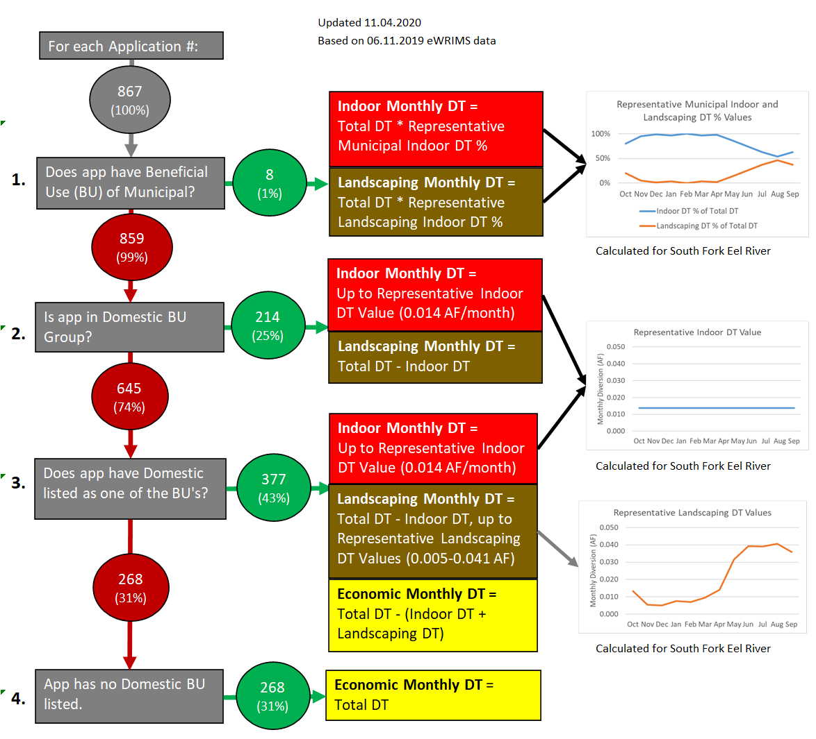
Figure 7.13 Logic tree for subdividing diverted total types.
Red circles represent the applications considered in each question. Green circles represent the applications meeting the criteria of the question.
The basin-wide calculated monthly DT for each DT type for the two scenarios is shown in Figure 7.14 and Figure 7.15. Economic DT has the largest volume for both scenarios.

Figure 7.14 Monthly diverted total by type for reported water use scenario.

Figure 7.15 Monthly diverted total by type for permitted water use scenario.

Estimating indoor diverted total
To estimate indoor DT, a subset of the eWRIMS data was created from the applications with domestic listed as the sole BU that contain the average annual reported DT (outlier applications were removed). The average reported monthly DTs for each application were calculated, with the month of minimum DT assumed to represent the indoor DT for each application. The median of these reported indoor DT values was 0.014 acre-feet/month (0.168 acre-feet/year). This 0.014 acre-feet/month value is used as the baseline indoor DT value (Figure 7.13). This representative indoor DT value equates to 150 gallons per day and represents AU for 2.7 people per application, given California’s 55 gallons/person/day standard for indoor use in SB 606 and AB 1668 (California State Office of Governor, 2018).
Estimating the indoor DT for municipal BU group applications was achieved by multiplying the total monthly DT by the representative municipal indoor DT % value for the month (Figure 7.16). These representative values were found by summing the monthly reported DT for the max year for all municipal applications, assuming the minimum monthly sum to be indoor, and then back-calculating the indoor % of total.

Figure 7.16 Representative municipal indoor and landscaping diverted total % values.

Estimating landscaping diverted total
To estimate landscaping DT, a dataset was created from the applications that list domestic as the sole BU and that contain an annual reported DT value during the year of maximum use (with outliers removed). The water diverted for landscaping per month was calculated with the following equation:
Equation 7.3 Calculating representative landscaping diverted total (single application) value.
Representative Landscaping DT Value= Monthly reported DT of each application (-) minimum monthly reported DT value of the application
where the minimum monthly DT value is assumed to represent indoor DT.
The mean of all representative landscaping DT (single application) values was calculated to provide monthly representative landscaping DT values. The representative landscaping DT and domestic DT values are shown in Figure 7.17 and Table 7.6.

Figure 7.17 Representative indoor and landscaping diverted total values.
Table 7.6 Representative indoor and landscaping diverted total values.
 | Annual | Oct | Nov | Dec | Jan | Feb | Mar | Apr | May | Jun | Jul | Aug | Sep
Indoor DT | 0.17 | 0.014 | 0.014 | 0.014 | 0.014 | 0.014 | 0.014 | 0.014 | 0.014 | 0.014 | 0.014 | 0.014 | 0.014
Landscaping DT | 0.25 | 0.013 | 0.005 | 0.005 | 0.008 | 0.007 | 0.010 | 0.014 | 0.032 | 0.039 | 0.039 | 0.041 | 0.036
Total Domestic DT | 0.41 | 0.027 | 0.019 | 0.019 | 0.021 | 0.021 | 0.023 | 0.028 | 0.045 | 0.053 | 0.053 | 0.054 | 0.050
All estimates in AF
The representative landscaping DT values range from 0.005 acre-feet (December) to 0.041 acre-feet (August) with an annual value of 0.25 acre-feet. Note that the monthly pattern for the representative landscaping DT values is affected by permitted DT, including both direct diversions and diversions to storage. Diversions to storage are often only allowed during winter months when landscape water demand is low.
The resulting annual estimate for representative total domestic DT (representative indoor plus landscaping DT values) is 0.41 acre-feet per year (366 gallons per day). This estimate of 366 gallons/day/household for the SFER watershed is close to the average residential AU in California of 362 gallons/day/household (DeOreo, 2011).
Landscaping DT for municipal applications was estimated by multiplying the total monthly DT by the representative municipal landscaping DT % value for the month (Table 7.6).

Examples of subdividing into DT types
Figure 7.18 illustrates how DT types were subdivided based on BU. The four examples all have identical monthly and annual DT values, but different values for each DT type.
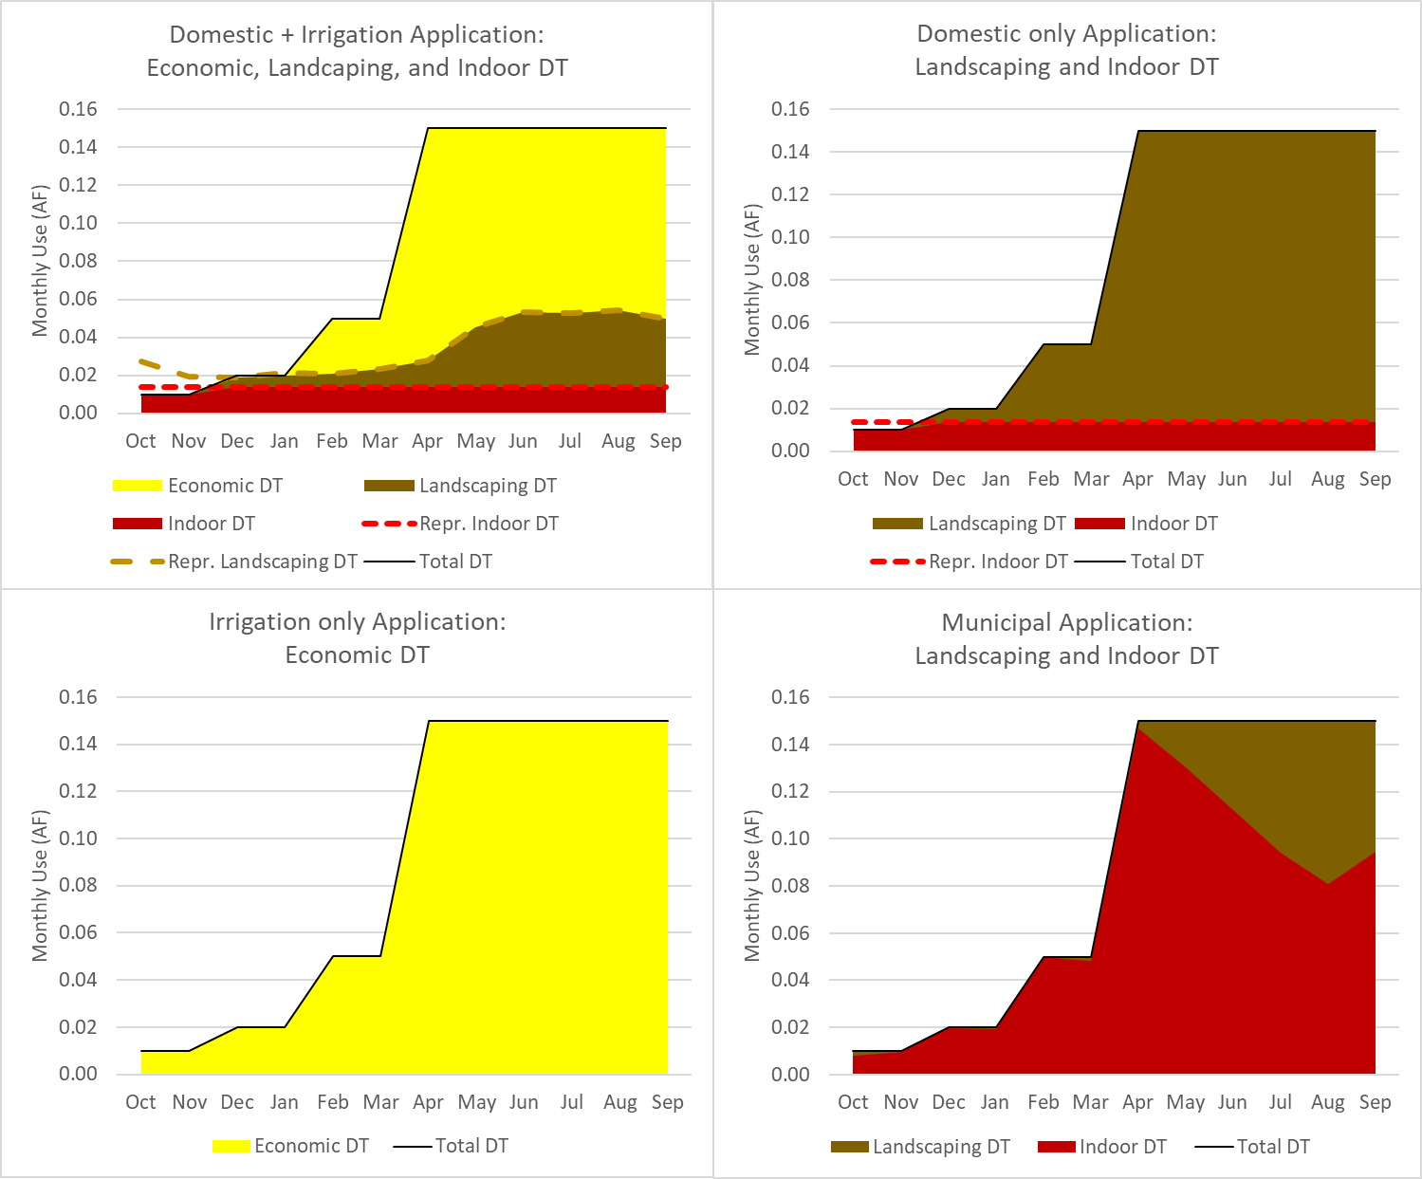
Figure 7.18 Subdividing diverted total types for an example application.

Classifying applications into beneficial use groups
The eWRIMS database contains beneficial use (BU) categories for each application. To facilitate estimates in the case of data gaps, the applications were classified into BU Groups in order to lump similar applications together. The logic tree for classifying each application into a BU group is shown in Figure 7.19.
Figure 7.19 Beneficial use group classification logic tree.
Red circles represent the applications considered in each question. Green circles represent the applications meeting the criteria of the question.
The BU Group classification process is described below.
- Cannabis (Permitted) (10%)
Any application with a water right type of Registration Cannabis.
- Municipal (1%)
Any non-cannabis application with a BU of municipal.
- Irrigation (56%)
Any non-cannabis or municipal application with a BU of irrigation.
- Recreation (2%)
Any non-cannabis, municipal, or irrigation application with a BU of recreation.
- Stockwatering (4%)
Any non-cannabis, municipal, irrigation, or recreation application with a BU of stockwatering.
- Domestic (25%)
Any non-cannabis, municipal, irrigation, or stockwatering application with a BU of domestic.
- Other (3%)
Any application not fitting into one of the six above categories.
The monthly DT of each BU Group for the reported (Figure 7.20 and Table 7.7) and permitted (Figure 7.21 and Table 7.8) scenarios are shown below. The irrigation BU Group has the highest DT for both scenarios.

Figure 7.20 Monthly eWRIMS diverted total by beneficial use group in reported water use scenario.

Table 7.7. Monthly eWRIMS diverted total by beneficial use group in reported water use scenario.
BU group | Annual | Oct | Nov | Dec | Jan | Feb | Mar | Apr | May | Jun | Jul | Aug | Sep
Cannabis (Permitted) | 48 | 1 | 9 | 7 | 10 | 6 | 9 | 1 | 1 | 1 | 1 | 1 | 1
Municipal | 647 | 54 | 46 | 44 | 45 | 43 | 45 | 44 | 50 | 58 | 69 | 80 | 69
Irrigation | 1425 | 96 | 316 | 52 | 98 | 106 | 94 | 67 | 74 | 122 | 145 | 143 | 112
Recreation | 42 | 2 | 2 | 3 | 4 | 5 | 5 | 5 | 5 | 3 | 3 | 3 | 3
Stockwatering | 23 | 2 | 2 | 2 | 2 | 2 | 2 | 1 | 1 | 2 | 2 | 2 | 2
Domestic | 1069 | 89 | 85 | 86 | 88 | 75 | 76 | 71 | 70 | 100 | 116 | 115 | 98
Other | 461 | 38 | 36 | 37 | 36 | 33 | 37 | 37 | 39 | 48 | 40 | 40 | 39
All estimates in AF

Figure 7.21 Monthly eWRIMS diverted total by beneficial use group in permitted water use scenario.

Table 7.8. Monthly eWRIMS diverted total by beneficial use group in permitted water use scenario.
BU group | Annual |  | Oct | Nov | Dec | Jan | Feb | Mar | Apr | May | Jun | Jul | Aug | Sep
Cannabis (Permitted) | 59 |  | 0 | 14 | 10 | 14 | 9 | 13 | 0 | 0 | 0 | 0 | 0 | 0
Municipal | 2155 |  | 174 | 177 | 164 | 163 | 153 | 164 | 143 | 161 | 174 | 208 | 255 | 219
Irrigation | 2511 |  | 100 | 236 | 244 | 262 | 250 | 267 | 75 | 307 | 371 | 137 | 139 | 124
Recreation | 65 |  | 3 | 5 | 7 | 9 | 8 | 9 | 5 | 6 | 4 | 4 | 4 | 3
Stockwatering | 33 |  | 2 | 3 | 3 | 4 | 3 | 3 | 3 | 2 | 2 | 2 | 2 | 3
Domestic | 637 |  | 43 | 50 | 58 | 67 | 60 | 64 | 51 | 51 | 57 | 51 | 43 | 40
Other | 493 |  | 43 | 37 | 37 | 36 | 33 | 37 | 38 | 47 | 49 | 43 | 45 | 47
All estimates in AF

Motivation behind beneficial use groups
The 867 water rights applications in the SFER watershed contain 17 different individual BUs in eWRIMS. A single application may possess several BUs, with the most common combinations shown in Figure 7.22. BU groups, aggregating applications with similar combinations of BUs, were defined to simplify the modeling process. This allowed monthly distribution and DT type assumptions to apply to these BU Groups as a whole. Figure 7.23 shows the number of applications in each sorted BU Group.

Figure 7.22 Most common beneficial use combinations.
DOM=domestic; FIRE=fire protection; IRR=irrigation; STOCK=stockwatering.

Figure 7.23 Number of applications in each beneficial use group.

Beneficial use group selection analysis
An explanation behind why these BU Groups were chosen and how the applications were sorted into each group is provided below.
The Cannabis (permitted) BU group is composed of Cannabis Small Irrigation Use Registrations (Registration Cannabis). All Registration Cannabis applications were categorized as cannabis (permitted) to facilitate scenarios in which these water rights are considered separately from all others.
Municipal applications are unique in reflecting diversions applying to many users within the service area. For this reason, any applications that contain municipal as a BU were categorized into the municipal BU group.
The irrigation BU group is the largest BU group by number of applications (56%) and also by volume of diversions. As seen in Figure 7.24 through Figure 7.26, when applications list a BU of irrigation in addition to other BUs, the diverted volumes are typically dominated by irrigation. Therefore, all non-cannabis, non-municipal applications that list irrigation as a BU were categorized as Irrigation BU. As seen in Figure 7.24, the mean DT volumes for the Irrigation BU Group, and those applications containing a BU of irrigation-only, are quantitatively similar. This observation supports the assumption that irrigation represents the dominant use for these applications.

Figure 7.24 Classifying irrigation applications.
The recreation BU group is relatively small in number of applications (2% of applications) and also in mean DT volume. As seen in Figure 7.25, applications with BUs of both recreation and irrigation have AU similar to irrigation-only. For this reason, those applications with BUs of both recreation and irrigation were categorized into the irrigation BU group. Applications containing both recreation and domestic have similar AU to those with domestic-only. However, these applications were left in the recreation BU group, as they contain monthly distributions distinct from the domestic BU group.

Figure 7.25 Classifying recreation applications.
The stockwatering BU group (4% of total applications) includes those applications that list stockwatering as the sole BU. As seen in Figure 7.26, applications that list both stockwatering and irrigation as BUs have mean reported DT values more similar to irrigation than to stockwatering.

Figure 7.26 Classifying stockwatering applications.
The domestic BU group (25% of applications) represents those applications whose use is predominantly residential indoor use (dishwashing, showering, cooking, etc.) and landscaping use (lawn watering, gardening, etc.) with no significant economic use of water. The volumes of water used in applications that include economic BUs (including cannabis, municipal, irrigation, stockwatering, and recreation) typically dwarf AU reported in applications that list domestic as the sole BU. As seen in Figure 7.27, applications included in the domestic BU group are similar in mean reported DT to those with domestic listed as the sole BU.

Figure 7.27 Classifying domestic applications.

Calculating average monthly distributions by beneficial use group
For those applications not containing explicit monthly distributions of DT, the average monthly DT distributions for each BU Group were used to estimate the monthly DT distribution. Three sets of distributions were calculated: the average monthly reported DT distribution, average monthly allowed DT distribution, and the average monthly reported AU distribution. In addition, an annual value for each BU group was assigned a reported DT: Face Value ratio in this section.

Average monthly reported DT distributions
The average monthly reported DT distributions were used to fill in data gaps to approximate the monthly timing of when water right holders choose to divert water. The average monthly reported DT distributions were applied to the 100 applications (12%) in the reported water use scenario that use a face value and/or allowed DT to determine the annual DT (see the logic tree in Figure 7.6). The average monthly reported DT distributions were also applied to the 199 applications (23%) in the permitted water use scenario that contain both allowed DT and face value (see the logic tree in Figure 7.8). Figure 7.28 and Table 7.9 show the average monthly reported DT distributions by BU Group.
Figure 7.28 Average reported diverted total distributions by beneficial use group.
Table 7.9 Average reported diverted total distributions by beneficial use group.
BU Group | Oct | Nov | Dec | Jan | Feb | Mar | Apr | May | Jun | Jul | Aug | Sep
Cannabis (Permitted) | 3% | 14% | 10% | 14% | 9% | 13% | 7% | 9% | 6% | 6% | 5% | 4%
Domestic | 6% | 7% | 9% | 9% | 8% | 8% | 8% | 9% | 10% | 10% | 9% | 8%
Irrigation | 7% | 7% | 7% | 11% | 9% | 9% | 8% | 9% | 9% | 9% | 8% | 7%
Recreation | 7% | 5% | 7% | 5% | 5% | 5% | 6% | 12% | 14% | 14% | 12% | 7%
Stockwatering | 10% | 13% | 13% | 9% | 9% | 8% | 5% | 5% | 7% | 7% | 7% | 7%

The average monthly reported DT distributions were determined by the following process:
- All the applications with non-zero annual reported DT were binned for each BU group.
- Outlier applications were removed.
- The mean reported DT for each month for each BU group was calculated.
The cannabis (permitted) average monthly reported DT distribution includes DT in the summer months, while regulations for Registration Cannabis water right types do not allow summer diversion. This is because the distribution is based on Water Use Reports from Statements of Use not subject to these regulations that have since been converted into Registration Cannabis rights. However, when this reported distribution is used for cannabis applications, the adjustments based on allowed DT prevent any modeled DT during summer months for these applications (described in step 4 of the permitted water use scenario logic tree in Figure 7.8).

Average monthly allowed diverted total distributions
The average monthly allowed DT distributions were used to fill in data gaps to approximate the monthly timing of when permits allow users to divert water. The allowed distributions were applied to 40 applications (5%) in the permitted water use scenario that have a face value, providing an annual DT, but have no allowed DT to calculate monthly DT. Figure 7.29 and Table 7.10 show the average monthly allowed DT distributions by BU Group.
Figure 7.29 Average monthly allowed diverted total distributions by beneficial use group.
Table 7.10 Average monthly allowed diverted total distributions by beneficial use group.
BU Group | Oct | Nov | Dec | Jan | Feb | Mar | Apr | May | Jun | Jul | Aug | Sep
Cannabis (Permitted) | 0% | 20% | 21% | 21% | 19% | 21% | 0% | 0% | 0% | 0% | 0% | 0%
Domestic | 6% | 9% | 11% | 12% | 11% | 12% | 9% | 8% | 7% | 6% | 4% | 4%
Irrigation | 5% | 13% | 13% | 13% | 12% | 13% | 3% | 2% | 6% | 6% | 6% | 6%
Recreation | 2% | 8% | 15% | 20% | 18% | 20% | 3% | 3% | 3% | 3% | 3% | 3%
Stockwatering | 8% | 9% | 9% | 9% | 8% | 9% | 9% | 8% | 8% | 8% | 8% | 8%
To calculate these distributions, all the applications with non-zero annual Allowed DT were gathered for each BU Group. The outlier applications were removed, then the mean allowed DT for each month for each BU Group was taken to be the average monthly permitted DT distribution.

Average monthly reported amount used distributions
Average monthly reported AU distribution (with storage) were used to fill in data gaps to approximate the monthly timing of when water right holders who utilize storage choose to use and apply the water. The average monthly reported AU distributions were applied to the 118 (14% of total applications) that declare storage, but contain no reported AU. See step 5 of the AU logic tree in Figure 7.10. This estimate was calculated as follows:
- All applications with non-zero annual reported AU were binned by BU group.
- Outlier applications were removed.
- Mean reported monthly AU values were calculated.
- The mean reported AU value for each month was divided by the mean annual AU value for the BU group to produce the average monthly reported AU distribution.
The distributions are shown in Figure 7.30 and Table 7.11.
Figure 7.30 Average reported monthly amount used distribution by beneficial use group.
Table 7.11 Average reported monthly amount used distribution by beneficial use group.
BU group | Oct | Nov | Dec | Jan | Feb | Mar | Apr | May | Jun | Jul | Aug | Sep
Cannabis (Permitted) | 7% | 3% | 4% | 4% | 4% | 5% | 7% | 10% | 14% | 14% | 14% | 13%
Domestic | 8% | 5% | 7% | 5% | 5% | 6% | 7% | 10% | 11% | 13% | 12% | 10%
Irrigation | 10% | 4% | 4% | 4% | 4% | 4% | 7% | 11% | 13% | 14% | 13% | 12%
Recreation | 10% | 7% | 8% | 6% | 6% | 7% | 8% | 9% | 10% | 11% | 10% | 7%
Stockwatering | 6% | 10% | 9% | 10% | 10% | 10% | 6% | 6% | 8% | 8% | 8% | 8%

Calculating average ratios of reported diverted total: face value
The average ratios of reported DT: face value (Rep: FV ratio) were used to fill in data gaps to approximate the portion of the face value which users typically have reported diverting. Analysis of the eWRIMS reveals that many users report significantly less DT than is allowed by their face value. The ratios were applied to 100 applications (12%) in the reported water use scenario which only have data for the face value or allowed DT, but have no water use reports. For these application, the Rep: FV ratio was used to produce estimated reported DT based on the face value according to Equation 7.4 shown below. Table 7.12 shows the Rep: FV ratio for each BU group. Ratios were not calculated for the municipal or other BU groups because no applications in these groups required the use of the Rep:FV Ratio.
Equation 7.4 Calculating estimated reported diverted total using Rep:FV ratio.
Estimated Reported DT (in reported scenario)= Face Value*Rep:FV ratio
Table 7.12 Rep:FV Ratios.
BU Group | Rep: FV Ratio | # of applications using the ratio | # of applications ratio calculation was based on
Cannabis (Permitted) | 0.73 | 67 | 10
Domestic | 0.63 | 36 | 45
Irrigation | 0.54 | 1 | 12
Recreation | 0.34 | 0 | 4
Stockwatering | 0.9 | 3 | 5

To calculate the Rep:FV Ratio for each BU group, the following steps were taken:
- All the applications with non-zero annual reported DT and face value were binned for each BU group.
- Outlier applications were removed .
- The Rep:FV Ratio was calculated from remaining applications according to Equation 7.5
Equation 7.5 Calculating Rep:FV ratio.
$$Rep:FV Ratio = \frac{Sum: Max Annual Reported {DT}^{'}s for BU Group}{Sum: Face Values for BU Group}$$

Priorities of eWRIMS applications
In WEAP, a priority must be assigned to each water demand in order to properly simulate the curtailment of supply during water shortages. The priority may be defined according to the user as a combination of the seniority date and the DT type. An important feature of SEWAM is the flexibility to assign priorities based on the needs of the model user. It is also important that the priority structure incorporate water rights seniority dates.
The priority date for Appropriative Applications used to determine water right seniority in this model was set to the application’s Received Date in eWRIMS. For the 80 applications that do not have a Received Date, the Acceptance Date was used instead. To reflect the seniority of pre-1914 and riparian applications, priority dates were set to arbitrary years of 1800 and 1700 respectively.

Cannabis imagery demand estimates
In addition to the water right demands from the eWRIMS database, monthly DT and AU estimates were calculated for the SEWAM model to represent cannabis imagery demand sites.
The SFER watershed is in one of the largest cannabis-producing regions in the United States (Wilson, 2018; Shields, 2018). A 2015 study estimated that cannabis water demands range from 23-173% of the seven-day annual low flow for tributaries of the South Fork Eel (Bauer et al, 2015). As of March 2018, it has been reported that fewer than 1% of cannabis growers in California have received cannabis farming permits from the State of California (Wilson, 2018).
Due to the scarcity of data from cannabis permitting and other sources, satellite imagery was used to develop a dataset of cultivation site locations, sizes, and types (indoor, outdoor, or mixed). For this reason, the DT and AU values calculated in this section are referred to as Cannabis imagery. They are distinct from the cannabis (permitted) DT and AU values associated with the Cannabis Registration water rights applications in eWRIMS.
The area of indoor and outdoor cannabis cultivation sites in the SFER watershed was assembled from multiple aerial imagery sources, discussed in section 7.4.1. Water use per area was estimated according to the methodology discussed 0 and 7.4.3, then applied to the cultivation areas to produce monthly AU estimates shown in Figure 7.31. below. The DT estimates varied according to the different sensitivity scenario model run in the SEWAM simulation, discussed in section 7.4.4.
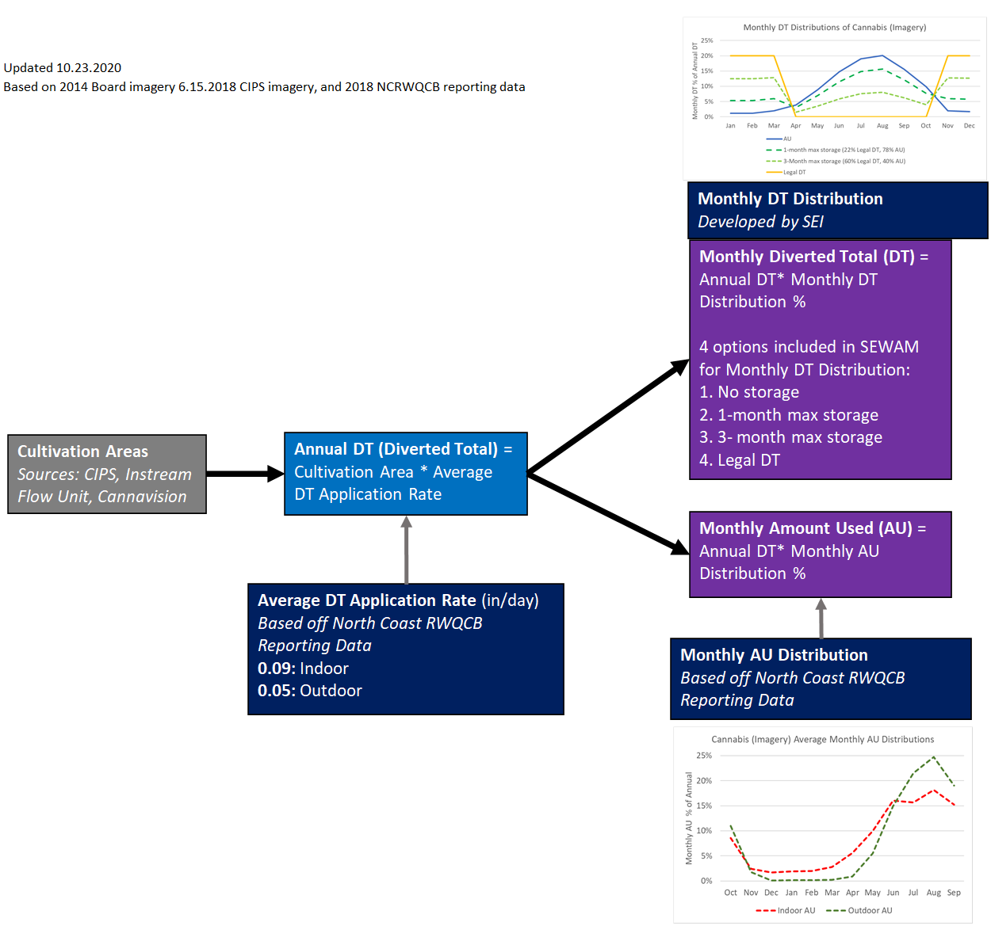
Figure 7.31 Cannabis imagery diverted total and amount used logic tree.

Estimating cannabis imagery cultivation area
To estimate the areas of cannabis cultivation, aerial imagery data was utilized from the following sources:
- State Water Board’s Cannabis Identification and Prioritization System (CIPS) database (June 2018)
- South Fork Eel imagery from the State Water division of water rights (2014)
- Cannavision (2018)
The grow sites identified in the SFER watershed are summarized in Figure 7.32 and Table 7.13. Grow sites identified by imagery as “greenhouse” or “greenhouse shaped” were assigned as indoor. Grow sites identified by imagery as “outdoor”, “cannabis grow”, “cannabis site – no growth”, or “potential” were assigned as outdoor.
Figure 7.32 Cannabis cultivation areas from imagery in the SFER.
Source: State Water Resources Control Board: CIPS (2018), Division of Water Rights (2014), Cannavision (2018)
Table 7.13 Cannabis cultivation area from imagery in the SFER.
 | # Polygons | Mean Polygon Size (ft²) | Total Cultivation Area (Acres)
Outdoor | 4,232 | 3,422 | 332
Indoor | 3,869 | 1,411 | 125
Total | 8,101 | 2462 | 457
Source: State Water Resources Control Board: CIPS (2018), Division of Water Rights (2014), Cannavision (2018)

Estimating cannabis imagery annual diverted total
Reported data on DT and AU for cannabis grow sites and greenhouses in the North Coast Region were collected by the North Coast Regional Water Quality Control Board (NC RWQCB) for the year 2017. This dataset was analyzed to calculate average cannabis water demand that can be applied to the cannabis imagery data, resulting in a cannabis imagery DT dataset for the SFER.
To estimate the DT of the cultivation sites described above, data were obtained from the Cannabis Cultivation Waste Discharge Regulatory Program of the NC RWQCB. The dataset originates from annual reports submitted in 2018 reflecting site conditions during the 2017 cultivation year. The dataset was reduced by NC RWQCB staff to the 608 reports in Humboldt, Trinity, Mendocino, and Sonoma counties that were prepared by professional consultants with cultivation areas less than an acre. The dataset contains monthly data on cultivation area, grow type, monthly direct diversion, and monthly diversion to storage for each record.
To estimate the annual DT of the cultivation areas, an average DT application rate was calculated for each cultivation type as follows:
- Diversions to storage and direct diversions were summed and divided by the cultivation area to obtain an average water application rate in inches/day for each cultivation type,
- The highest and lowest 10% of the rates for each type were removed to eliminate outliers,
- The mean water application rate was calculated to provide the average DT application rate.
The average DT application rates range from 0.05 inches/day for outdoor cultivation to 0.09 inches/day for indoor cultivation (Table 7.14). The dataset contained 191 indoor reports, 125 mixed (mixed indoor and outdoor cultivation) reports, and 131 outdoor reports.
Table 7.14 Average diverted total application rates for cannabis imagery areas.
Calculated from NC RWQCB, 2017
Cultivation Type | Average DT Application Rate (Inches/Day)
Indoor | 0.09
Outdoor | 0.05

Estimating cannabis imagery monthly amount used distribution
Similar to the eWRIMS applications, the cannabis imagery areas were assigned a monthly distribution of the AU timing. The total annual AU is set equal to the annual DT calculated according to section 7.4.2. A pattern of average monthly AU distribution was calculated from the NC RWQCB 2017 dataset for both indoor and outdoor cultivation sites, shown in Figure 7.33 and Table 7.15.
The average monthly AU distributions were calculated as follows:
- Only those cultivation areas with zero diversion to storage were isolated in the dataset.
- The highest 10% and lowest 10% of inches/day of annual AU were discarded from indoor and outdoor datasets to remove outliers.
- Across all remaining reporting sites, the mean AU for each month is divided by the mean annual AU to calculate the average monthly AU distribution (Figure 7.33 and Table 7.15).

Figure 7.33 Monthly amount used distributions for cannabis imagery areas.
Calculated from NC RWQCB, 2017.

Table 7.15 Monthly amount used distributions for cannabis imagery areas
Calculated from NC RWQCB, 2017
 | Oct | Nov | Dec | Jan | Feb | Mar | Apr | May | Jun | Jul | Aug | Sep
Indoor AU | 9% | 2% | 2% | 2% | 2% | 3% | 5% | 10% | 16% | 16% | 18% | 15%
Outdoor AU | 11% | 2% | 0% | 0% | 0% | 0% | 1% | 6% | 15% | 21% | 25% | 19%

Estimating cannabis imagery monthly diverted total distribution
In SEWAM, the cannabis imagery areas were simulated under several sensitivity scenarios, with differing assumptions regarding on-site water storage. While the monthly AU distribution remained constant under each sensitivity scenario, the monthly DT distribution varied to reflect the storage assumptions. The monthly DT distribution associated with each storage assumption are detailed below:
- No storage. Monthly DT = Monthly AU
- 1-month max storage. Monthly DT = 78% * Monthly AU + 22% * Legal DT pattern. Percentages were calculated so that a representative site (with average portions of indoor and outdoor areas) would store, at a maximum, a volume equal to the highest 1 month of AU.
- 3-month max storage. Monthly DT = 40% * Monthly AU + 60% * Legal DT pattern. Percentages were calculated so that a representative site (with average portions of indoor and outdoor areas) would store, at a maximum, a volume equal to the highest 3 months of AU.
- Legal DT pattern. Assumes a constant 20% DT for each month from Nov-Mar, the period when cannabis sites permitted under eWRIMS are allowed to divert.
The monthly DT distributions are summarized in Table 7.16 below. The monthly DT distributions are calculated in Figure 7.34 for a representative site (with average portions of indoor and outdoor areas). Note that an individual cannabis site’s DT distribution may differ slightly from that in Figure 7.34 depending on its portion of indoor and outdoor areas.
Table 7.16 Monthly diverted total distributions based on storage assumptions for cannabis imagery areas.
Storage assumption | % AU monthly distribution | % legal DT monthly distribution
AU (no storage) | 100% | 0%
1-month max storage | 78% | 22%
3-months max storage | 40% | 60%
Legal DT | 0% | 100%

Figure 7.34 Average monthly diverted total distributions for cannabis imagery areas.
The no storage DT distribution sets the DT equal to the AU for each timestep, so that no on-site storage is accumulated. For the no storage DT distribution, the DT peaks in the summer, and low in the winter. Compared to no storage, the 1-month max storage DT distribution is more spread out, with relatively lower diversions in the summer and higher diversions in the winter. The 3-month max storage DT distribution more closely approximates the legal DT distribution, with higher winter diversions than summer diversions. The legal DT pattern only allows diversion from the wetter months of Nov-Mar.

The total estimated AU and DT demands for each set of storage assumptions is shown below in Figure 7.35 and Table 7.17. In the basin-wide results calculated in section 7.2 for the reported and permitted water use scenarios, the DT from the 1-month max storage DT distribution is used for cannabis imagery, as it most closely approximates the expected conditions in the SFER, as estimated by the State Water Board.

Figure 7.35 Cannabis imagery diverted total and amount used totals for South Fork Eel River.

Table 7.17 Cannabis imagery diverted total and amount used totals for South Fork Eel River.
Storage assumption | Annual | Oct | Nov | Dec | Jan | Feb | Mar | Apr | May | Jun | Jul | Aug | Sep
AU (no storage) | 849 | 87 | 17 | 7 | 7 | 7 | 10 | 22 | 65 | 131 | 161 | 188 | 148
1-month max storage | 849 | 67 | 51 | 43 | 43 | 43 | 45 | 17 | 50 | 102 | 126 | 147 | 115
3-months max storage | 849 | 35 | 109 | 105 | 105 | 105 | 106 | 9 | 26 | 52 | 64 | 75 | 59
Legal DT | 849 | 0 | 170 | 170 | 170 | 170 | 170 | 0 | 0 | 0 | 0 | 0 | 0
All estimates in AF

Estimating cannabis imagery return flows

The return flows are calculated based off the AU and the consumptive use fraction, in the same manner as that for the eWRIMS applications as previously described in section 7.3.2 with Equation 7.1 repeated below.

Equation 7.1 Calculating return flow (originally appears in section 7.3.2).
Return Flow=Amount Used*(1-Consumptive Use Fraction)
The consumptive use fractions for cannabis imagery are set to 80%. This figure is based off the assumptions established in Table 7.5, where all AU types related to growing vegetation are set to 80% consumptive use to account for crop evapotranspiration.

Illegal domestic demand estimates
SEWAM includes illegal domestic demand sites, in addition to the eWRIMS and cannabis imagery demands previously documented. The illegal domestic sites represent household water use for buildings in the watershed not included within an eWRIMS application or municipal water service area.
This section highlights the estimation process shown in Figure 7.36 below, where population estimates associated with illegal domestic demands (section 7.5.1) are multiplied by an annual AU/capita (section 7.5.2) and a monthly AU/capita (section 7.5.3) to calculate monthly AU/subwatershed. These sites were assumed to have no on-site storage, and so monthly DT = monthly AU.
Figure 7.36 Illegal domestic amount used logic tree.

Population for illegal domestic demands
To calculate illegal domestic demands, the population of illegal domestic water users in the SFER watershed was first calculated. First, for each region, the 2010 census population was divided by the total square footage of building footprints from the Microsoft Building Footprints dataset (available at: https://hub.arcgis.com/datasets/bb69f10baf334d4c935a0fb23d758f38_0) (Microsoft, 2019) to calculate a figure of population/building square footage. Then, those buildings outside of municipal California Drinking Water System Area Boundaries (available at https://gis.data.ca.gov/datasets/fbba842bf134497c9d611ad506ec48cc_0) (SWRCB, 2020) and within 1,000 feet of an available stream source were isolated, to represent those buildings which draw supply from local surface diversions. The total population associated with the illegal domestic demands was estimated at 3,296 for the SFER watersheds. The buildings associated with the illegal domestic demands are shown below in Figure 7.37.
Figure 7.37 Buildings associated with illegal domestic demands in the South Fork Eel River.

Estimating illegal domestic annual amount used per capita
Once the population associated with the illegal domestic demands was estimated, an annual AU per capita figure was calculated in order to assign annual illegal domestic AU’s to each SFER subwatershed. The eWRIMS data was used to calculate an average annual AU/capita of 100 gallons/capita/day, according to the following steps:
- A dataset was populated consisting of eWRIMS applications in the SFER with a domestic BU group, a non-zero reported DT value, and a non-zero population associated with the application in the eWRIMS flat file.
- A gal/cap/day figure was calculated for each application in the dataset based on the application’s maximum reported year DT value.
- Outliers were removed from the data set, including applications with > 10 population, < 10 gal/cap/day, or > 1,000 gal/cap/day.
- The median gal/cap/day was calculated from the remaining applications.

Estimating illegal domestic monthly amount used distribution
The annual AU for the illegal domestic demands was multiplied by a monthly distribution to calculate monthly AU/capita, in a process similar to that for the eWRIMS and cannabis imagery demands. The average reported monthly AU distribution for the domestic BU group from the eWRIMS applications in Table 7.11 was multiplied the annual average of 100 gal/cap/day calculated in 7.5.2 to calculate the illegal domestic monthly AU/capita shown below in Figure 7.38 and Table 7.18.

Figure 7.38 Illegal domestic monthly amount used per capita.

Table 7.18 Illegal domestic monthly amount used per capita.
 |  | Oct | Nov | Dec | Jan | Feb | Mar | Apr | May | Jun | Jul | Aug | Sep
Gal/Person/Day |  | 94 | 61 | 82 | 71 | 65 | 71 | 85 | 118 | 134 | 153 | 141 | 122

The total annual AU for the illegal domestic demand sites is 374 AF, as shown below in Table 7.19. Note that the monthly DT = monthly AU since it is assumed there is no on-site storage.
Table 7.19 Illegal domestic total amount used and diverted total in South Fork Eel River.
Annual | Oct | Nov | Dec | Jan | Feb | Mar | Apr | May | Jun | Jul | Aug | Sep
374 | 30 | 19 | 26 | 22 | 19 | 22 | 26 | 37 | 41 | 49 | 45 | 37

Estimating illegal domestic consumptive use fraction and return flows
The return flows for the illegal domestic demands are calculated based off the AU and the consumptive use fraction, in the same manner as that for the eWRIMS applications as previously described in section 7.3.2 with Equation 7.1 repeated below.

Equation 7.1 Calculating return flow (originally appears in section 7.3.2).
Return Flow = Amount Used * (1-Consumptive Use Fraction)
The consumptive use fraction was set to 43% for all illegal domestic demands, based off the eWRIMS domestic reporting data according to the following steps:

- A dataset was populated from those eWRIMS applications in the SFER which are in the domestic BU group, are determined to have no storage, and have a non-zero annual AU in the year where the maximum reported DT occurs.
- To identify those applications which have a conventional use pattern, the dataset was isolated to those which have non-zero reported AU values in all months and which do not report identical AU values in all months.
- The minimum monthly value of AU was taken to represent the indoor AU for all months for each application. Remaining water use for each application was assumed to represent landscaping AU.
- The mean indoor and landscaping % of total annual AU was calculated across all applications in dataset.
- Based on Table 7.5, consumptive use fractions were assigned as 0% for indoor AU and 80% for landscaping AU, to yield a consumptive use fraction of 28%.
- An additional 15% loss was added to account for system losses (per Water Board staff) to yield a final consumptive use fraction of 43%.

Department of Drinking Water municipal demand estimates
SEWAM includes DDW municipal demands, in addition to the eWRIMS, cannabis imagery, and illegal domestic demands previously documented. The DDW municipal demands represent municipal water use for service areas not included in eWRIMS. Briceland CSD and Phillipsville CSD were identified as municipal providers which report surface water diversions to the DDW, but are not permitted in eWRIMS.
This section contains the monthly AU (section 7.6.1) and consumptive use fractions and return flows (7.6.2) assigned to the DDW municipal demands. These sites were assumed to have no on-site storage, and so monthly DT = monthly AU.

Estimating DDW municipal amount used
The AU estimates for Briceland CSD and Phillipsville CSD were taken from the DDW monthly reporting data in the year of highest reported surface water use.
These figures were then divided by 0.85 to account for a 15% system loss from the point of diversion, with the resulting monthly AU estimates shown in Table 7.20 below.
Table 7.20 Municipal DDW amount used estimates.
 | Report Year | Annual | Oct | Nov | Dec | Jan | Feb | Mar | Apr | May | Jun | Jul | Aug | Sep
Briceland CSD | 2013 | 13 | 1.1 | 0.9 | 1.1 | 0.7 | 0.6 | 0.8 | 0.8 | 1.3 | 1.2 | 1.5 | 1.6 | 1.4
Phillipsville CSD | 2015 | 58 | 4.0 | 3.5 | 4.3 | 5.0 | 4.2 | 6.0 | 6.0 | 6.5 | 5.1 | 5.2 | 4.1 | 4.2
All estimates in AF

Estimating DDW municipal consumptive use fraction and return flows
The return flows for the DDW municipal demands are calculated based off the AU and the consumptive use fraction, in the same manner as that for the eWRIMS applications as previously described in section 7.3.2 with Equation 7.1 repeated below.

Equation 7.1 Calculating return flow (originally appears in section 7.3.2).
Return Flow = Amount Used * (1-Consumptive Use Fraction)
The consumptive use fraction for all DDW municipal demands was set equal to the 43% used for illegal domestic demands, calculated in section 7.5.4.

References
Bauer, Scott & Olson, Jennifer & Cockrill, Adam & van Hattern, Michael & Miller, Linda & Tauzer, Margaret & Leppig, Gordon. 2015. “Impacts of Surface Water Diversions for Marijuana Cultivation on Aquatic Habitat in Four Northwestern California Watersheds. PLOS ONE 10(9): e0137935. https://journals.plos.org/plosone/article?id=10.1371/journal.pone.0120016
California Department of Fish and Wildlife (CDFW). 2018. “South Fork Eel River Watershed Studies”. https://www.wildlife.ca.gov/Conservation/Watersheds/Instream-Flow/Studies/South-Fork-Eel-Study
California Natural Resources Agency (CNRA). 2014. “California Water Action Plan.” http://resources.ca.gov/docs/california_water_action_plan/2014_California_Water_Action_Plan.pdf
California State Office of Governor. 2018. “Governor Brown Signs Legislation Establishing Statewide Water Efficiency Goals. https://www.ca.gov/archive/gov39/2018/05/31/governor-brown-signs-legislation-establishing-statewide-water-efficiency-goals/index.html
California State Water Resources Control Board. 2018. “eWRIMS – Electronic Water Rights Information System”. http://ciwqs.waterboards.ca.gov/ciwqs/ewrims/EWPublicTerms.jsp
California State Water Resources Control Board (2017). “Using Innovative Technology to Monitor Compliance-Case Study: The Cannabis Identification and Prioritization System (CIPS). Sacramento, CA.
DeOreo, William. 2011. “California Single Family Water Use Efficiency Study”. Aquacraft Water Enginering & Management. Boulder, CO. https://www.irwd.com/images/pdf/savewater/CaSingleFamilyWaterUseEfficiencyStudyJune2011.pdf
Johnson, Julie. 2018. “Annual Northern California cannabis harvest underway as pot economy transitions”. The Press Democrat. Santa Rosa, CA. https://www.pressdemocrat.com/news/8778434-181/annual-cannabis-harvest-underway-in
Legislative Analyst’s Office (LAO). 2017. “Residential Water Use Trends and Implications for Conservation Policy”. Sacramento, CA. https://lao.ca.gov/Publications/Report/3611
Nylen, Nell & Kiparsky, Michael & Owen, Dave & Doremus, Holly & Hanemann, Michael. 2018. “Addressing Institutional Vulnerabilities in California’s Drought Water Allocation”. University of California, Berkeley. Berkeley, CA.
Purkey, D. and A. Huber-Lee. 2006. “A DSS for long-term water utility planning.” Southwest Hydrology. 4. pp. 18-31
Purkey, D., A. Huber-Lee, D. Yates, and M. Hanemann. 2007. “Integrating a climate change assessment tool into stakeholder-driven water management decision-making processes in California”. Water Resources Management, 21, pp. 315-329.
Shields, Jim. 2018. “The Observer: Water rules may cap cultivation”. The Ukiah Daily Journal. Ukiah, CA. https://www.ukiahdailyjournal.com/2018/01/25/the-observer-waters-rules-may-cap-cultivation/
US Census Bureau (Census). 2017. “QuickFacts: Humboldt County, California” & “QuickFacts: Mendocino County, California”. Suitland, MD. https://www.census.gov/quickfacts/humboldtcountycalifornia
US Geological Survey (USGS). 2005. “California Precipitation”. Reston, VA. https://nationalmap.gov/small_scale/printable/images/pdf/precip/pageprecip_ca3.pdf
Wilson, Scott. 2018. “Outlaw weed comes into the light”. The Washington Post. Washington, DC. https://www.washingtonpost.com/news/national/wp/2018/03/16/feature/californias-outlaw-marijuana-culture-faces-a-harsh-reckoning-legal-weed/?noredirect=on&utm_term=.df3b7ed30742
Yates, D., D. Purkey, H. Galbraith, A. Huber-Lee, and J. Sieber. 2005. “WEAP21--A Demand-, Priority-, and Preference-Driven Water Planning Model: Part 2, Aiding Freshwater Ecosystem Service Evaluation”. Water International, 30, 4, pp. 501-512
Yates, D., H. Galbraith, D. Purkey, A. Huber-Lee, J. Sieber, J. West, S. Herrod-Julius, and B. Joyce, 2008: “Climate warming, water storage, and Chinook salmon in California's Sacramento Valley”. Climatic Change, 91, 335-350, doi:10.1007/s10584-008-9427-8.
Yates, D., D. Purkey, J. Sieber, A. Huber-Lee, H. Galbraith, J. West, S. Herrod-Julius, C. Young, B. Joyce, and M. Rayej. 2009. “Climate Driven Water Resources Model of the Sacramento Basin, California”. ASCE Journal of Water Resources Planning and Management, 135, pp. 303-313
Yates, D., J. Sieber, D.R. Purkey and A. Huber-Lee. 2005. “WEAP21--A Demand-, Priority-, and Preference-Driven Water Planning Model: Part 1, Model Characteristics”. Water International, 30, pp. 487-500. www.weap21.org/downloads/WEAPDSS.pdf

Since the original SacWAM guide was written, WEAP has been updated to allow demand priorities and supply preferences from 1 to 999 999 999. This change accommodates using dates (such as water rights issuance dates in the format YYYYMMDD) as demand priorities. This demand priority range can be set under Basic Parameters in the General WEAP menu.
Applications with only domestic listed as a BU were used to ensure that the DT is isolated to only domestic.
The maximum year of reported DT was not used to estimate Indoor DT because it is assumed that Indoor DT does not significantly vary in drought conditions.
Applications with annual average reported DT > 10 acre-feet/ were removed from the Indoor DT dataset, as they represent outliers that would dominate the effect of smaller applications. Applications with a minimum monthly DT of 0 were also removed from because they reflect a lack of permission to divert water during certain months rather than a lack of demand for of Indoor DT demand.
The median is used to calculate indoor DT because a typical, representative Indoor DT is desired.
The reported DT was taken from the year of maximum DT for Landscaping DT in order to represent landscaping during possible drought or curtailment situations.
Applications with annual maximum reported DT > 10 acre-feet/year were removed from the Landscaping DT dataset, as they represent outliers that would dominate the effect of smaller applications. Applications that had months containing DT values of 0 were removed as well because they represent a lack of permission to divert water during certain months rather than a lack of Landscaping DT demand. Applications that reported identical DT each month were removed as well, as it was assumed that they reflect erroneous monthly reporting.
The mean was used to calculate the representative Landscaping DT values because the irregular pattern of 0 values from the Permitted DT period distort the median.
For the reported distributions, the applications with reported DT>100 acre-feet/year were determined to represent reporting errors or extreme outliers and were removed. From the remaining applications, the highest and lowest 5% of DT values were removed from each BU group, as they represent outliers that would distort the mean.
For the average monthly Permitted DT distributions, the applications with the highest and lowest 5% Allowed DT’s for each BU group were removed, as they represent outliers that would distort the mean.
The applications with Reported AU > 100 acre-feet/year represent reporting errors and extreme outliers and were removed. From the remaining applications, the highest and lowest 5% of AU values were removed from each BU group, as they represent outliers that would distort the mean.
Only those applications with (1) maximum Annual DT < Face Value (others are illegal or a reporting error), (2) maximum annual DT > 5% of Face Value (discards outliers), and (3) Face Value < 50 AF (discards outliers) were entered into the dataset. Of these values in the dataset, the largest 10% of Face Values and the largest 10% of (Face Value maximum annual DT) values were removed from each BU group (these values all represent outliers that would distort the mean and dominate the effect of smaller applications).

